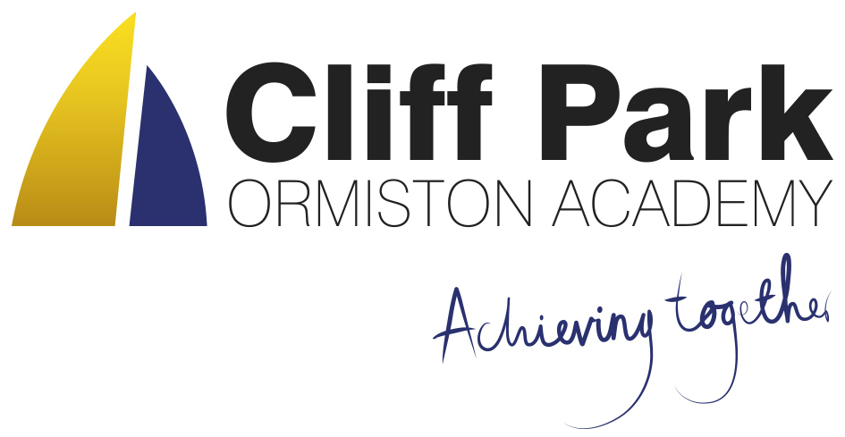
Kennedy Avenue, Gorleston-on-Sea
Great Yarmouth, Norfolk NR31 6TA
Tel: 01493 661504
Email: enquiries@cliffparkoa.co.uk
Web: www.cliffparkoa.co.uk
Facebook: Cliff Park Ormiston Academy
Instagram: @CliffParkOrmistonAcademy

18th June 2026

Dear Parent / Carer

Re: Temporary Summer Uniform During Hot Weather

As we are expecting a period of hot weather, we will be making a temporary adjustment to our uniform expectations.

During this period, students should attend school wearing:
- Plain black school trousers or a plain black school skirt
- A white school shirt
- No tie
- No blazer
Full PE kit should still be brought to school on the days it is needed for PE.
Please can parents/carers support us by ensuring students arrive in the correct summer uniform each day. Students should also bring a refillable water bottle and are encouraged to drink regularly throughout the day.

We will continue to review the weather and will confirm when normal uniform expectations resume.

Thank you for your continued support.

Yours sincerely


Mr H French
Principal

