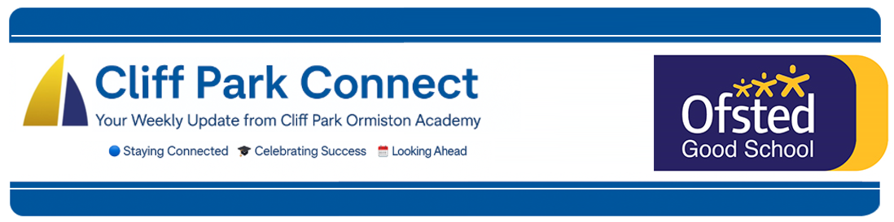
2025 / 26 Volume 10
28th November 2025
Dear Parents / Carers,
Welcome to Cliff Park Connect – your weekly window into life at Cliff Park Ormiston Academy.
Year 12 Presentation Evening
This week we were delighted to welcome back our former Year 11 students for our annual Presentation Evening, a special event where we celebrate the achievements, character, and resilience of the Class of 2024/5.
It was wonderful to see so many of our students return looking confident, mature, and ready for the next stage of their journeys. Families, staff, and governors joined together to acknowledge not only exam results, but also the determination, attendance, commitment, and personal growth that sat behind those successes.
Our guest speaker for the evening was Mr Pillar, who is retiring this year after an exceptional career at Cliff Park. He spoke with warmth about community, aspiration, and the values that will carry young people into their future pathways.
Throughout the evening, awards were presented for:
- Outstanding academic achievement
- Exceptional progress
- Resilience and personal development
A huge well done to every student recognised, and a sincere thank you to the families who have supported them throughout their time with us. Their success is very much a shared achievement.
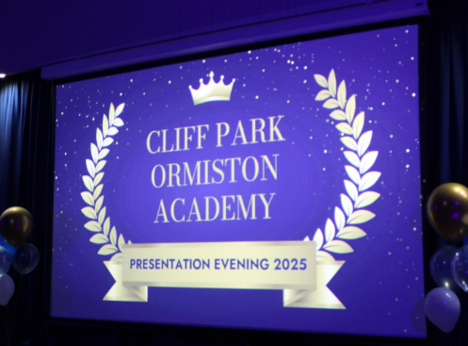
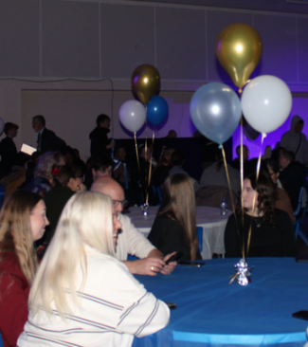
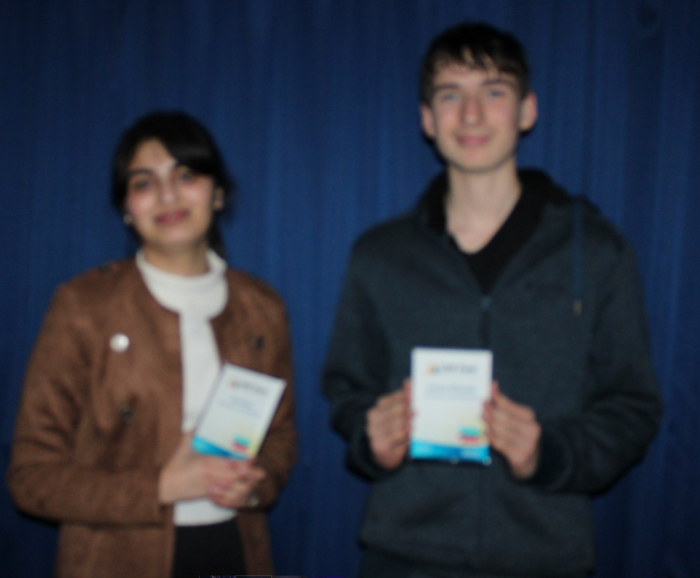
We are incredibly proud of this year group and look forward to seeing all they will continue to accomplish in their next steps.

Careers Day Success
On Thursday we held our annual Careers Day, a fantastic opportunity for students in Years 7–11 to engage directly with employers, training providers and further education organisations. The day was designed to broaden aspirations, deepen understanding of future pathways, and give students meaningful encounters with professionals from a wide range of industries.
We were proud to welcome an exceptional range of visitors, including:
University of East Anglia, East Norfolk Sixth Form College, Lowestoft Sixth Form, Norfolk Fire & Rescue, HM Prison & Probation Service, Royal Air Force, University Technical College Norfolk, Sizewell C, Ormiston Teacher Training, Hunter’s Yard, Into University, Lucas & Wyllys Solicitors, the Sea Cadet Corps, and several additional community partners
Our visitors commented on the excellent engagement of Cliff Park students, praising their curiosity, confidence, and respectful questions. It was a real credit to the academy and a powerful reflection of our CARE values in action. We are incredibly grateful to all the organisations who gave their time and expertise to support our young people.
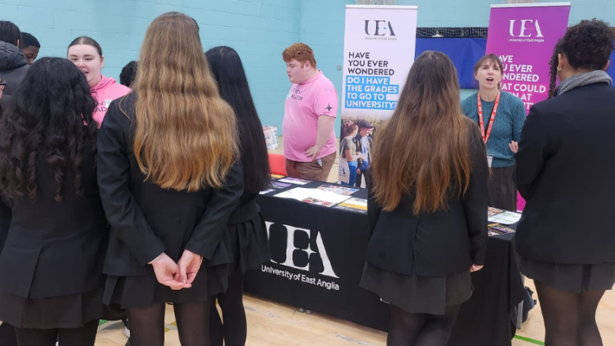
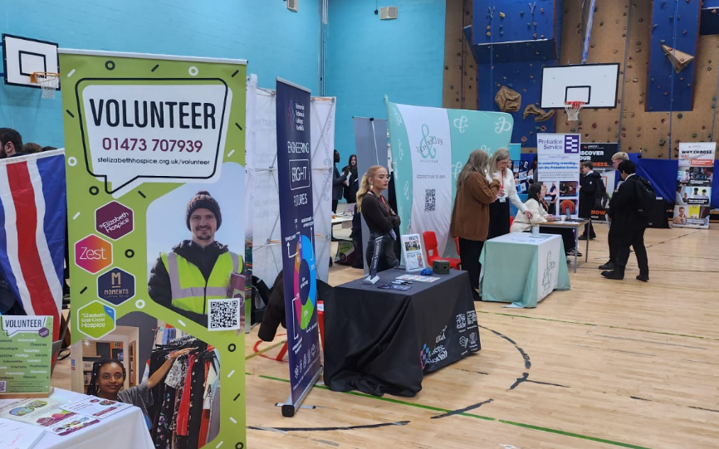
Parking Outside the Academy – Keeping Students Safe
You will be aware that safety cones have been placed along the zig-zag area outside school to prevent cars from mounting the pavement. Recently, this has created an unsafe situation for students during busy drop-off and pick-up times.
Student safety remains our top priority, and keeping the pavement clear is essential.
Thank you to the many parents and carers who already park responsibly. We really appreciate your support.
We do, however, ask all families to please:
- Avoid stopping or parking on zig-zag lines
- Keep crossing points unobstructed
- Use designated drop-off areas wherever possible
- Drive slowly and with heightened awareness
Your cooperation helps us maintain a safe environment for every child.
Thank you for continuing to work with us.
Stay Connected – Follow Us on Facebook and Instagram
Want to stay up to date with the latest news, events, and celebrations from Cliff Park Ormiston Academy? Make sure you’re following us on social media!
Our Facebook and Instagram pages are the best way to get a behind-the-scenes look at life at Cliff Park – from student achievements and classroom highlights to important updates and upcoming events.

Follow us today:
Facebook: Cliff Park Ormiston Academy
Instagram: @CliffParkOrmistonAcademy
We’re proud of our students and everything they’re achieving – come and see for yourself what makes Cliff Park such a special place to learn.

Help Us Celebrate Your Child’s Success!
At Cliff Park Ormiston Academy, we love to celebrate the achievements of our students – both in and out of school. Whether it’s a sporting success, a creative talent, community involvement or a personal milestone, we want to hear about it!

If your child has achieved something you’re proud of, big or small, we’d love the chance to share it with our school community through our newsletters and social media channels.

How to share:
Please email a short description and, if possible, a photo to CPOAnews@cliffparkoa.co.uk

Thank you for helping us shout about all the brilliant things happening beyond the classroom!
Main reception Opening Hours
Opening hours for our main reception – 8.00 am to 4.00 pm Monday to Thursday. 8.00 am to 3.30pm on a Friday. Telephone 01493 661504 option 2 or email enquiries@cliffparkoa.co.uk

Parent Forum Next Date
Our next Parent Forum will take place on Thursday 18th December at 6.00PM, and we look forward to welcoming even more families to be part of the discussion.

SEND drop in reminder
If you have any concerns or questions around SEND, Parents and Carers are invited to attend a SEND drop in session which is held at the academy every Tuesday morning 8.30 - 8.50am.

Parent Drop-In Tuesday pm or Wednesday am
Parents / Carers are welcome to drop into the academy to meet directly with myself or a member of my Senior Team in an informal setting every Tuesday 3.00 to 4.00 pm and every Wednesday 8.50 and 9.30 am. You do not need to make an appointment, please just come to reception and we will be happy to meet with you.

I understand the crucial role that parents play in a community school and welcome discussion on any aspect of our school community. Whether you have a question, some feedback, or simply want to have a conversation about life at Cliff Park, you are warmly welcome to drop in

We look forward to seeing you there and continuing to strengthen the partnership between school and home.

Unfortunately, we will not be able to see parents who drop into reception outside of this period except where there is a safeguarding concern.

Important Dates for your Diary
Date | Event
Friday 5th December | Staff Training Day
Thursday 18th December | Parent Forum
Friday 19th December | End of Autumn Term
Tuesday 6th January | Start of Spring Term (week 2)

Heads of Year Contact details
If you need to contact your child’s head of year please email them or call the main reception to pass a message on for you.
Year 7 - Ms Phillips ephillips@cliffparkoa.co.uk
Year 8 - Mrs Dudley ddudley@cliffparkoa.co.uk
Year 9 - Mr Warnes mwarnes@cliffparkoa.co.uk
Year 10 - Miss Harris mharris@cliffparkoa.co.uk
Year 11 - Mr Callaby rcallaby@cliffparkoa.co.uk

Thank you for supporting us in maintaining the high standards that we know you expect from Cliff Park Ormiston Academy.
Yours sincerely

Harry French
Principal

