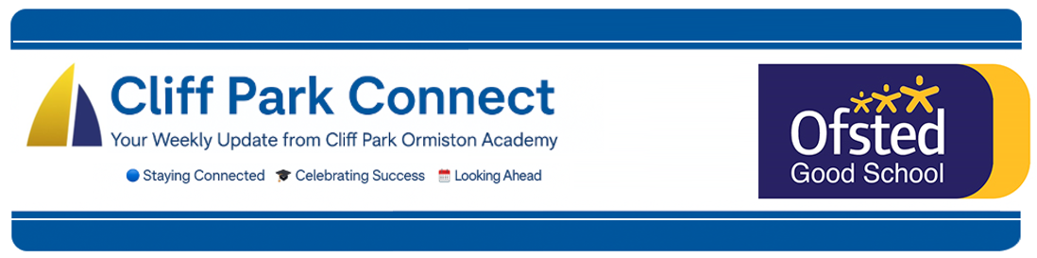
2025 / 26 Volume 11
12th December 2025
Dear Parents / Carers,
Welcome to Cliff Park Connect – your weekly window into life at Cliff Park Ormiston Academy.

Christmas Dinner
Thank You for a Wonderful Christmas Dinner!
I wanted to say a heartfelt thank you to all our students and parents for supporting our Christmas Dinner in Period 4 yesterday. It was a fantastic event. Students enjoyed a full Christmas dinner, festive music and a really warm, joyful atmosphere across the hall.
Events like this are only possible because of the positivity and support of our school community, and it was brilliant to see everyone coming together to celebrate the end of term.
Thank you once again for helping make it such a memorable occasion.
Football Success
A huge congratulations to our Year 10 team, who secured an outstanding 8–0 victory against Acle, and to our Year 8 team for their impressive 3–2 win over Sprowston. Both teams progress to the next round of the Norfolk County Cup.
Both squads demonstrated excellent teamwork, determination and sportsmanship throughout. We are incredibly proud of their efforts and the way they represented the academy.
Parent Forum
Our next Parent Forum will take place on Thursday 18th December at 6.00PM, and we look forward to welcoming even more families to be part of the discussion.

Please use this link to join the meeting https://tinyurl.com/jkupwbk3

Year 11 Mock Exam Results
Today our students received their mock exam results, and we want to offer a message of encouragement to every single one of them.

Whatever your child’s results look like, remember this: mocks are a starting point, not a finish line. Mock exams are designed to help students understand where they are now, so they can focus their energy in the right places over the coming months.

We believe in every student and we will continue to support them every step of the way. To our brilliant students: Keep working hard, keep attending, keep asking for help, and keep pushing yourself. Small, consistent effort from now until the summer will make a huge difference.

Work Experience
Year 10 students will be completing a week long Work Experience during the week beginning 29th June 2026. They have received their letters and information on how to log their placement on our online system, Unifrog. It is important that students begin finding their placements now so that they have a guaranteed position.

All details can be found on our website here: Cliff Park Ormiston Academy - Careers Guidance
Parking Outside the Academy – Keeping Students Safe
You will be aware that safety cones have been placed along the zig-zag area outside school to prevent cars from mounting the pavement. Recently, this has created an unsafe situation for students during busy drop-off and pick-up times.
Student safety remains our top priority, and keeping the pavement clear is essential.
Thank you to the many parents and carers who already park responsibly. We really appreciate your support.
We do, however, ask all families to please:
- Avoid stopping or parking on zig-zag lines
- Keep crossing points unobstructed
- Use designated drop-off areas wherever possible
- Drive slowly and with heightened awareness
Your cooperation helps us maintain a safe environment for every child.
Thank you for continuing to work with us.
Stay Connected – Follow Us on Facebook and Instagram
Want to stay up to date with the latest news, events, and celebrations from Cliff Park Ormiston Academy? Make sure you’re following us on social media!
Our Facebook and Instagram pages are the best way to get a behind-the-scenes look at life at Cliff Park – from student achievements and classroom highlights to important updates and upcoming events.

Follow us today:
Facebook: Cliff Park Ormiston Academy
Instagram: @CliffParkOrmistonAcademy
We’re proud of our students and everything they’re achieving – come and see for yourself what makes Cliff Park such a special place to learn.

Help Us Celebrate Your Child’s Success!
At Cliff Park Ormiston Academy, we love to celebrate the achievements of our students – both in and out of school. Whether it’s a sporting success, a creative talent, community involvement or a personal milestone, we want to hear about it!

If your child has achieved something you’re proud of, big or small, we’d love the chance to share it with our school community through our newsletters and social media channels.

How to share:
Please email a short description and, if possible, a photo to CPOAnews@cliffparkoa.co.uk

Thank you for helping us shout about all the brilliant things happening beyond the classroom!
Main reception Opening Hours
Opening hours for our main reception – 8.00 am to 4.00 pm Monday to Thursday. 8.00 am to 3.30pm on a Friday. Telephone 01493 661504 option 2 or email enquiries@cliffparkoa.co.uk

Parent Forum Next Date
Our next Parent Forum will take place on Thursday 26th March 2026 at 6.00PM, and we look forward to welcoming even more families to be part of the discussion.

SEND drop in reminder
If you have any concerns or questions around SEND, Parents and Carers are invited to attend a SEND drop in session which is held at the academy every Tuesday morning 8.30 - 8.50am.

Parent Drop-In Tuesday pm or Wednesday am
Parents / Carers are welcome to drop into the academy to meet directly with myself or a member of my Senior Team in an informal setting every Tuesday 3.00 to 4.00 pm and every Wednesday 8.50 and 9.30 am. You do not need to make an appointment, please just come to reception and we will be happy to meet with you.

I understand the crucial role that parents play in a community school and welcome discussion on any aspect of our school community. Whether you have a question, some feedback, or simply want to have a conversation about life at Cliff Park, you are warmly welcome to drop in

We look forward to seeing you there and continuing to strengthen the partnership between school and home.

Unfortunately, we will not be able to see parents who drop into reception outside of this period except where there is a safeguarding concern.

Important Dates for your Diary
Date | Event
Friday 19th December | End of Autumn Term
Tuesday 6th January | Start of Spring Term (week 2)
Thursday 15th January | Y11 Parents Evening / Pre-Mock Information
Thursday 29th January | Y9 Parents Evening
Thursday 12th February | Parents Forum 6.00 pm
Friday 13th February | Finish for Half Term Break
Tuesday 24th February | Students return after Half Term Break (Week 2)
Thursday 23rd April | Y8 Parents Evening
Thursday 30th April | Y7 Parents Evening

Heads of Year Contact details
If you need to contact your child’s head of year please email them or call the main reception to pass a message on for you.
Year 7 - Ms Phillips ephillips@cliffparkoa.co.uk
Year 8 - Mrs Dudley ddudley@cliffparkoa.co.uk
Year 9 - Mr Warnes mwarnes@cliffparkoa.co.uk
Year 10 - Miss Harris mharris@cliffparkoa.co.uk
Year 11 - Mr Callaby rcallaby@cliffparkoa.co.uk

Thank you for supporting us in maintaining the high standards that we know you expect from Cliff Park Ormiston Academy.
Yours sincerely

Harry French
Principal

