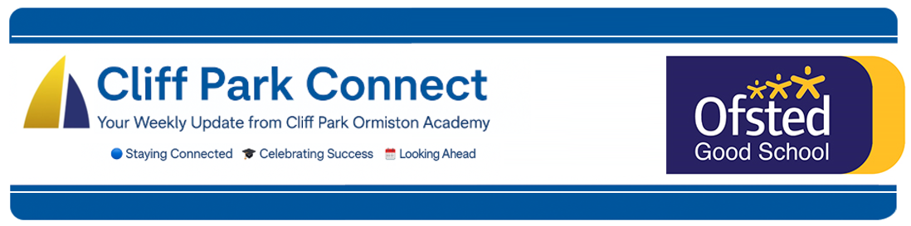
2025 / 26 Volume 7
17th October 2025
Dear Parents / Carers,
Welcome to Cliff Park Connect – your weekly window into life at Cliff Park Ormiston Academy.

Use of James Paget Hospital – Out of Bounds Before and After School
With immediate effect, the toilets and Cafe at James Paget University Hospital are out of bounds to all Cliff Park students before and after school.
This decision follows a number of complaints from hospital staff and patients regarding groups of students congregating in and around the hospital at the start and end of the school day. In addition to these complaints, there has been recent damage caused to the facilities, which has understandably raised concerns for both the hospital and the academy.
To support students at the end of the day, the snack hatch in the Diner will be open daily between 3.00pm and 3.15pm, allowing students to purchase a drink or snack before they leave for home. Our own toilets remain open after school for any student who needs to use them before travelling home, removing any need to visit the hospital site.
We ask for your full support in reinforcing this message at home to ensure that all students represent the academy positively in our local community and respect the facilities of others.
​
Year 7 Make a Dream Start to Their Football Journey
It was a fantastic start to Year 7’s football life at Cliff Park, as they faced a strong Langley side in their opening fixture. From start to finish, the team delivered an outstanding performance across the pitch, resulting in an emphatic 9–0 victory.
The match showcased teamwork, determination, and real quality in every position. This impressive display marks what promises to be a very exciting season ahead. The entire squad were a credit to Cliff Park — a joy to watch and an honour to coach.

Year 10 football
Year 10 shook off the cobwebs with a well-deserved 3–2 victory over Attleborough Academy. It was fantastic to see the team back together after last year’s narrow loss in the County Cup final. The match showcased a strong all-round performance, with every player contributing to the result. With this promising start, the squad looks set to go from strength to strength as the season progresses. Well done to everyone.

PE kit reminder
We kindly remind all students that a full PE kit is required for all PE lessons. Bringing in and wearing the correct kit ensures students can take part safely and comfortably in all activities. Please check that your child has their PE kit on the appropriate days. Thank you for your support.

Free School Meals – Don’t Miss Out!
At Cliff Park Ormiston Academy, we want every student to have the best start to each school day. If your child is eligible for Free School Meals (FSM), we strongly encourage you to apply — it’s quick, confidential, and can make a big difference.
By taking up Free School Meals, students benefit from:
- A nutritious meal each day to help them concentrate and achieve their best in lessons.
- Access to additional support for learning, as the school receives extra funding (Pupil Premium) for every student registered.
- The reassurance that all applications are treated in confidence — no one can tell who is receiving Free School Meals.
If you think your child might be eligible, please check the criteria and apply online via https://www.norfolk.gov.uk/freeschoolmeals or contact the school office for support. Even if your child prefers to bring a packed lunch, registering still brings valuable additional funding to the academy.
For students already entitled to Free School Meals — we encourage you to make the most of this support every single day. A healthy lunch will fuel your learning, boost your energy, and help you get the very best from your time at Cliff Park.
Breakfast Club
We continue to offer a FREE breakfast for all our students. The Breakfast Club is available between 8.00AM and 8.25AM and all students are welcome.

Please could I remind parents to make sure that you have placed sufficient funds on your child’s Parent Pay account to help maintain the smooth running of the checkouts.

Parent Forum
We look forward to welcoming you to the next forum on Thursday 23rd October.
Please see below the video recording of our last forum which focused on our Ofsted report.
📺 Click to watch the Parent Forum on YouTube

Stay Connected – Follow Us on Facebook and Instagram
Want to stay up to date with the latest news, events, and celebrations from Cliff Park Ormiston Academy? Make sure you’re following us on social media!
Our Facebook and Instagram pages are the best way to get a behind-the-scenes look at life at Cliff Park – from student achievements and classroom highlights to important updates and upcoming events.

Follow us today:
Facebook: Cliff Park Ormiston Academy
Instagram: @CliffParkOrmistonAcademy
We’re proud of our students and everything they’re achieving – come and see for yourself what makes Cliff Park such a special place to learn.

Help Us Celebrate Your Child’s Success!
At Cliff Park Ormiston Academy, we love to celebrate the achievements of our students – both in and out of school. Whether it’s a sporting success, a creative talent, community involvement or a personal milestone, we want to hear about it!

If your child has achieved something you’re proud of, big or small, we’d love the chance to share it with our school community through our newsletters and social media channels.

How to share:
Please email a short description and, if possible, a photo to CPOAnews@cliffparkoa.co.uk

Thank you for helping us shout about all the brilliant things happening beyond the classroom!
Main reception Opening Hours
Opening hours for our main reception – 8.00 am to 4.00 pm Monday to Thursday. 8.00 am to 3.30pm on a Friday. Telephone 01493 661504 option 2 or email enquiries@cliffparkoa.co.uk

SEND drop in reminder
If you have any concerns or questions around SEND, Parents and Carers are invited to attend a SEND drop in session which is held at the academy every Tuesday morning 8.30 - 8.50am.

Parent Drop-In Tuesday pm or Wednesday am
Parents / Carers are welcome to drop into the academy to meet directly with myself or a member of my Senior Team in an informal setting every Tuesday 3.00 to 4.00 pm and every Wednesday 8.50 and 9.30 am. You do not need to make an appointment, please just come to reception and we will be happy to meet with you.

I understand the crucial role that parents play in a community school and welcome discussion on any aspect of our school community. Whether you have a question, some feedback, or simply want to have a conversation about life at Cliff Park, you are warmly welcome to drop in

We look forward to seeing you there and continuing to strengthen the partnership between school and home.

Unfortunately, we will not be able to see parents who drop into reception outside of this period except where there is a safeguarding concern.

Important Dates for your Diary
Date | Event
Thursday 23rd October | On-line Parents Forum
Friday 24th October | October Half Term
Monday 3rd November until Friday 21st November | Year 11 Mock Exams
Thursday 20th November | Year 12 Presentation Evening
Thursday 27th November | Careers Fair
Friday 28th November | Year 11 Mock Results
Friday 5th December | Staff Training Day
Thursday 18th December | Parent Forum
Friday 19th December | End of Autumn Term

Heads of Year Contact details
If you need to contact your child’s head of year please email them or call the main reception to pass a message on for you.
Year 7 - Ms Phillips ephillips@cliffparkoa.co.uk
Year 8 - Mrs Dudley ddudley@cliffparkoa.co.uk
Year 9 - Mr Warnes mwarnes@cliffparkoa.co.uk
Year 10 - Miss Harris mharris@cliffparkoa.co.uk
Year 11 - Mr Callaby rcallaby@cliffparkoa.co.uk

Thank you for supporting us in maintaining the high standards that we know you expect from Cliff Park Ormiston Academy.
Have a brilliant weekend.

Yours sincerely

Harry French
Principal

