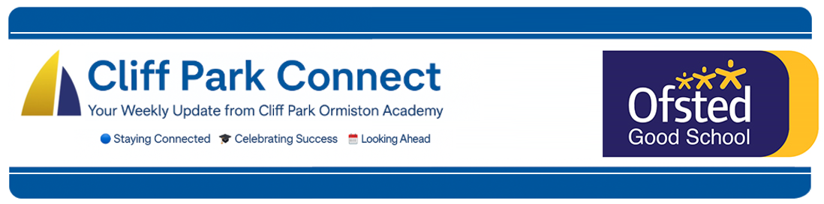
2025 / 26 Volume 6
10th October 2025
Dear Parents / Carers,
Welcome to Cliff Park Connect – your weekly window into life at Cliff Park Ormiston Academy.

Open Mornings
Tuesday 14th to Thursday 16th October 9.15am to 9.45am each morning.

We warmly welcome Year 6 parents considering Cliff Park Ormiston Academy, as well as current parents who would like to see the academy in action during a typical school day. Please scan the QR code to choose a convenient date for your visit.

Thank you for attending Year 11 Parents’ Evening
A huge thank you to all parents and carers who joined us for Year 11 Parents’ Evening. Your time, questions and encouragement make a real difference to our students as they head into their final year. Staff commented on the positive, focused conversations and the clear partnership between home and school exactly what our young people need to stay motivated and on track.
Next steps:
- Revision & support: Students have been given subject-specific targets and revision guidance. Period 6 sessions continue each week and we would be grateful if you could please encourage full attendance.
- Resources: All materials and recommended revision links will be made available on Class Charts. Further to parental feedback a web area containing past papers and revision resources will be created early next week for students.
- Attendance & routines: Strong attendance, punctuality and a consistent study routine at home will have the greatest impact between now and exams.
- Keeping in touch: If you have any follow-up questions, please contact your child’s subject teacher or tutor via the usual channels.
Thank you again for your ongoing support. Working together, we can ensure every student is confident, prepared and ready to succeed.
Year 8 Rugby
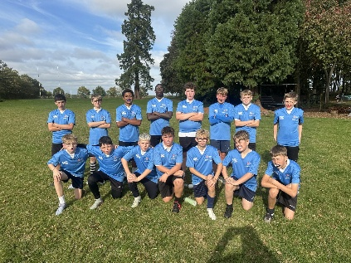
15 Year 8 boys took part in a rugby day at North Walsham. During the day the students were coached by the North Walsham senior coaches and first team players before a series of competitive matches against other schools. We hope the boys will continue to use these new found skills in some more fixtures!
PE kit reminder
We kindly remind all students that a full PE kit is required for all PE lessons. Bringing in and wearing the correct kit ensures students can take part safely and comfortably in all activities. Please check that your child has their PE kit on the appropriate days. Thank you for your support.
Reminder: Staff Training Day – Friday 17 October (Students not in school)
A quick reminder that Friday 17 October 2025 is a Staff Training (INSET) Day. The academy will be open for staff only and students are not required to attend.
Key points
- No lessons, clubs or Period 6 on Friday 17 October.
- Students return as normal on Monday 20 October.
- Our main reception will be open for enquiries during office hours.
Thank you for your support as we invest in training that helps us keep improving the education we provide.
East Norfolk Sixth Form College Open Event for Year 11 Students
I am pleased to share a special invitation from Dr Catherine Richards, Principal of East Norfolk Sixth Form College. Dr Richards would like to welcome all Cliff Park Year 11 students and their parents/carers to a dedicated Open Event at the Sixth Form College on Tuesday 14th October between 3.45pm and 4.30pm.
This event has been arranged exclusively for our students and their families. It takes place after our Parents’ Evening, ensuring that students can first receive valuable feedback from their teachers before exploring their post-16 options. The timing also ensures that students will not miss their Period 6 session on the day.
You can book your sixth form tour HERE
Free School Meals – Don’t Miss Out!
At Cliff Park Ormiston Academy, we want every student to have the best start to each school day. If your child is eligible for Free School Meals (FSM), we strongly encourage you to apply — it’s quick, confidential, and can make a big difference.
By taking up Free School Meals, students benefit from:
- A nutritious meal each day to help them concentrate and achieve their best in lessons.
- Access to additional support for learning, as the school receives extra funding (Pupil Premium) for every student registered.
- The reassurance that all applications are treated in confidence — no one can tell who is receiving Free School Meals.
If you think your child might be eligible, please check the criteria and apply online via https://www.norfolk.gov.uk/freeschoolmeals or contact the school office for support. Even if your child prefers to bring a packed lunch, registering still brings valuable additional funding to the academy.
For students already entitled to Free School Meals — we encourage you to make the most of this support every single day. A healthy lunch will fuel your learning, boost your energy, and help you get the very best from your time at Cliff Park.
Breakfast Club
We continue to offer a FREE breakfast for all our students. The Breakfast Club is available between 8.00AM and 8.25AM and all students are welcome.

Please could I remind parents to make sure that you have placed sufficient funds on your child’s Parent Pay account to help maintain the smooth running of the checkouts.

Parent Forum
We look forward to welcoming you to the next forum on Thursday 23rd October.
Please see below the video recording of our last forum which focused on our Ofsted report.
📺 Click to watch the Parent Forum on YouTube

Stay Connected – Follow Us on Facebook and Instagram
Want to stay up to date with the latest news, events, and celebrations from Cliff Park Ormiston Academy? Make sure you’re following us on social media!
Our Facebook and Instagram pages are the best way to get a behind-the-scenes look at life at Cliff Park – from student achievements and classroom highlights to important updates and upcoming events.

Follow us today:
Facebook: Cliff Park Ormiston Academy
Instagram: @CliffParkOrmistonAcademy
We’re proud of our students and everything they’re achieving – come and see for yourself what makes Cliff Park such a special place to learn.

Help Us Celebrate Your Child’s Success!
At Cliff Park Ormiston Academy, we love to celebrate the achievements of our students – both in and out of school. Whether it’s a sporting success, a creative talent, community involvement or a personal milestone, we want to hear about it!

If your child has achieved something you’re proud of, big or small, we’d love the chance to share it with our school community through our newsletters and social media channels.

How to share:
Please email a short description and, if possible, a photo to CPOAnews@cliffparkoa.co.uk

Thank you for helping us shout about all the brilliant things happening beyond the classroom!
Main reception Opening Hours
Opening hours for our main reception – 8.00 am to 4.00 pm Monday to Thursday. 8.00 am to 3.30pm on a Friday. Telephone 01493 661504 option 2 or email enquiries@cliffparkoa.co.uk

SEND drop in reminder
If you have any concerns or questions around SEND, Parents and Carers are invited to attend a SEND drop in session which is held at the academy every Tuesday morning 8.30 - 8.50am.

Parent Drop-In Tuesday pm or Wednesday am
Parents / Carers are welcome to drop into the academy to meet directly with myself or a member of my Senior Team in an informal setting every Tuesday 3.00 to 4.00 pm and every Wednesday 8.50 and 9.30 am. You do not need to make an appointment, please just come to reception and we will be happy to meet with you.

I understand the crucial role that parents play in a community school and welcome discussion on any aspect of our school community. Whether you have a question, some feedback, or simply want to have a conversation about life at Cliff Park, you are warmly welcome to drop in

We look forward to seeing you there and continuing to strengthen the partnership between school and home.

Unfortunately, we will not be able to see parents who drop into reception outside of this period except where there is a safeguarding concern.

Important Dates for your Diary
Date | Event
Friday 17th October | Staff Training day (No students in school)
Thursday 23rd October | On-line Parents Forum
Friday 24th October | October Half Term
Monday 3rd November until Friday 21st November | Year 11 Mock Exams
Thursday 20th November | Year 12 Presentation Evening
Thursday 27th November | Careers Fair
Friday 28th November | Year 11 Mock Results
Friday 5th December | Staff Training Day
Thursday 18th December | Parent Forum
Friday 19th December | End of Autumn Term

Heads of Year Contact details
If you need to contact your child’s head of year please email them or call the main reception to pass a message on for you.
Year 7 - Ms Phillips ephillips@cliffparkoa.co.uk
Year 8 - Mrs Dudley ddudley@cliffparkoa.co.uk
Year 9 - Mr Warnes mwarnes@cliffparkoa.co.uk
Year 10 - Miss Harris mharris@cliffparkoa.co.uk
Year 11 - Mr Callaby rcallaby@cliffparkoa.co.uk

Thank you for supporting us in maintaining the high standards that we know you expect from Cliff Park Ormiston Academy.
Have a brilliant weekend.

Yours sincerely

Harry French
Principal

