**Volume 5**

**4th July 2025**

Dear Parents / Carers,

**Welcome to *Cliff Park Connect* – your weekly window into life at Cliff Park Ormiston Academy.**

We want to extend our sincere thanks to all parents and carers for your unwavering support. Whether it’s encouraging your child each morning, attending meetings, supporting behaviour expectations, or working in partnership with us when challenges arise - your involvement makes a real difference.

**Top of the points**  
Well done to the following students who are Top of the Points this week, Eddie Yr 7, Marcel Yr 7, Miley Yr 8 and Oscar Yr 10. Wel done all!

**Duke of Edinburgh Navigation Walk - Friday 27th June**

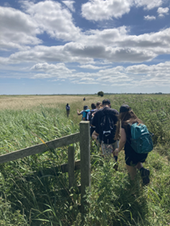Miss Lee and Mr Sewell took a group of students, who are working towards their Bronze Duke of Edinburgh, on a navigation walk.  Prior to the event the students attended both afterschool and break time sessions looking at map reading, orientating the map and navigation, and route planning.  We met as a group, a few days before, to discuss footwear and clothing, food and drinks and that all students needed to be aware of the weather conditions and ensure they had plenty of fluids and applied suntan lotion.

On the Friday we began our route in Halvergate, students learnt how to orientate the map, take a compass reading and headed off in the direction of travel.

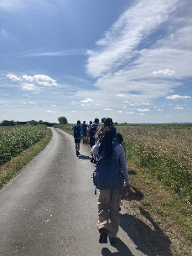Students learnt about the country code, walking on roads with no footpath and how to be considerate to other walkers.  We encountered livestock on the route and the students learnt how to pass, quietly, calf’s that had managed to escape the neighbouring fields.

Each of the three groups took responsibility for leading on parts of the walk with myself and Mr Sewell there for support and guidance.  A lunch spot was found and a suitable length to stop was discussed with students being given a task for the afternoon.  In the afternoon students learnt how to pace their walk, by using the scale on the map and walking at the pace of 1km every 20 minutes.

We arrived at our destination on time, and all were very pleased with their accomplishments, walking 11miles in just under 5 hours.

A huge congratulations to the group.  A big thank you to Mr Sewell for his support, on the day and in the background and to Mr Barrett for driving the minibus for us on that day.  I look forward to continuing their training and preparing them for the expedition.

**Year 6 Transition Days – A Fantastic Introduction to Life at Cliff Park Ormiston Academy**

Our recent Year 6 Transition Days were a great success, offering students a positive and engaging introduction to life at our school.

Over the course of their visits, pupils participated in a wide range of lessons, including Maths, English, Engineering, Drama, French, Photography, and Art. A particular highlight for many was the PE sessions, especially the ever-popular glow-in-the-dark dodgeball, which added a fun and energetic twist to the day.

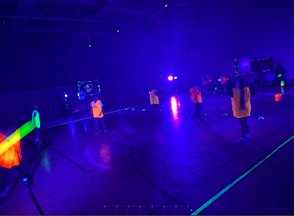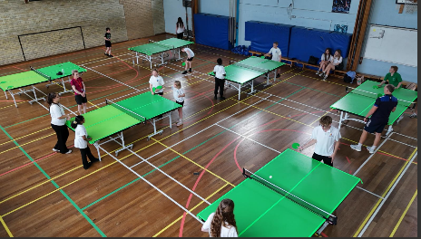In addition to their learning experiences, students had the chance to explore and understand our school’s core CARE values—Commitment, Aspiration, Respect, and Excellence—helping them feel confident, welcome, and well-prepared for the exciting journey ahead. We’re thrilled to have welcomed our future students and look forward to seeing them thrive as part of our school community.

**If you were unable to attend the Parent Information Evening on Monday – the link to a YouTube version of the presentation is** [**here**](https://gbr01.safelinks.protection.outlook.com/?url=https%3A%2F%2Fwww.youtube.com%2Fwatch%3Fv%3DRiVv7SUqrq8&data=05%7C02%7Cjspurgeon%40cliffparkoa.co.uk%7C9fa6a69e34404946f92708ddbaf56841%7Ce8bb2c7004dc48938882c47b54dbd292%7C1%7C0%7C638872285362242838%7CUnknown%7CTWFpbGZsb3d8eyJFbXB0eU1hcGkiOnRydWUsIlYiOiIwLjAuMDAwMCIsIlAiOiJXaW4zMiIsIkFOIjoiTWFpbCIsIldUIjoyfQ%3D%3D%7C0%7C%7C%7C&sdata=V%2BnhWtLc8G34O6EJZMNrowAP84%2FmQtCCAFzx8hAV15c%3D&reserved=0)

**Sports Day**

On Thursday we saw the first Sports Day at Cliff Park for 6 years.

It was a fantastic day had by all with some excellent new school records being created. The staff relay was a hit at the end, Mr Amoah needs to try out for the Olympics! The PE department are extremely proud of all students and staff who participated in the athletics events.

A massive well done! Be sure to check out the Facebook and Instagram pages for videos and pictures of the day. Certificates and medals will be handed out at the celebration assemblies.

**Year 11 Prom: A Night to Remember**

On Thursday evening, our Year 11 students came together for a truly unforgettable night at the Cliff Park Academy Prom. Held at the Royal Assembly Rooms, Great Yarmouth the event was a

celebration of friendship, achievement, and the end of a remarkable journey.

Students arrived in style, dressed to impress and full of excitement. The evening was filled with music, dancing, and plenty of photo opportunities, capturing memories that will last a lifetime. The Prom was a fitting send-off for a year group who have shown great resilience, character, and ambition.

A huge thank you to the staff who helped organise the evening and to everyone who supported behind the scenes to make it such a success.

We wish all our Year 11s the very best for the future.

**Exciting Art News**

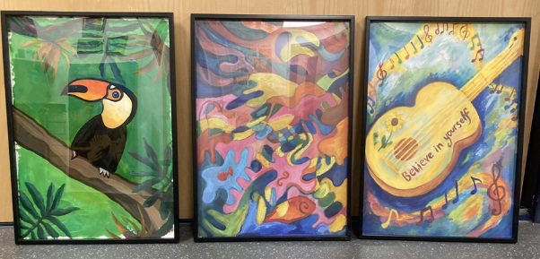Exciting news, in the Spring term our Art students were asked to participate in an Art competition being run by East Norfolk Sixth Form College on behalf of the James Paget Hospital.

The Brief was to help ‘update, The Cove’ Waiting room [in the teenager’s ward] by designing a piece of artwork for the space that would ‘reflect teenage interests and would be calming and intriguing to patients, distracting them from the stress which can be associated with hospitals. This brief was sent to all the local schools and some of our year7,8 and 9 students who attend Art club took on this challenge.

We are delighted to have been informed that the winning entries were Toby Kimble year 8, Abigail Saggers year 8 and Lily Keogh year 9. All Cliff Park winners! The winning entries have been re-created by some of the East Norfolk Sixth Form students and are framed and awaiting hanging.

Congratulations to all those that took part and especially our winners.

**Year 10 Work Experience**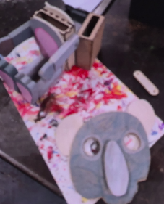

A huge congratulations to all of our Year 10 students who have completed work experience this week. We have had students attending a diverse range of employers, from school to engineering multinationals. We have even had some students working out of area in London. Could students please ensure they complete and bring back their work experience booklets, handing them to their Form Tutors on Monday.

Within school, some Year 10 have been engaging in a number of virtual work experience workshops. They have also created stop-motion animations based around our CARE Values and zoomorphic lamp in DT.

**Thank You & End of Term ‘Picnic in the Park’ Details**

We’d like to say a big **thank you to Danielle, Tesco Community Champion**, for generously providing snacks and water for our upcoming **‘Picnic in the Park’** event!

This celebration will take place on the **last day of term from 1pm to 3pm**, giving students a chance to come together as a school community, celebrate the brilliant work they’ve done this year, and enjoy time together before the summer break.

**Activities will include:**

* A **football tournament**
* A **colour run** (please send your child with old clothing if they’d like to take part)
* **Fete-style games and face glitter**

We’ll also have:

* **Two ice cream vans** on site (cash only)
* A **tuck shop** (cash only)

To help your child enjoy the afternoon comfortably, please ensure they bring:

* A **water bottle**
* **Sun cream and a hat**
* **Cash** for any treats they'd like to buy

If you would like to make a **donation** to support the event, please contact us at:  
📧 **CPOANews@cliffparkoa.co.uk**

Thank you for your continued support—we’re looking forward to a fantastic end-of-year celebration!

**Staying Safe Around Water:**

As the warmer months approach and more young people spend time outdoors, we want to take a moment to highlight the importance of **water safety**. Whether it’s swimming pools, rivers, lakes, canals, or the sea, being near open water can pose serious risks—especially for children and teenagers.

While water can seem inviting and fun, it’s essential that young people understand how to stay safe.

**Key Water Safety Tips to Share with Your Child:**

* **Never swim alone.** Always be with a trusted adult or friend in safe, supervised areas.
* **Stick to lifeguarded areas** whenever possible.
* **Cold water can be dangerous.** Even in summer, open water can cause cold water shock, which can affect breathing and coordination.
* **Avoid jumping or diving** into water unless you’re certain of the depth and what’s beneath the surface.
* **Stay away from weirs, fast-moving currents, and locks**, especially in canals and rivers.
* **Don’t use inflatables** on open water like rivers or the sea—they can easily drift.

**What Parents and Carers Can Do:**

* Talk openly with your child about the risks, especially around unsupervised swimming or tombstoning.
* Encourage them to look out for friends and to seek help if someone is in trouble—**never go in after someone; call 999 immediately**.
* Consider enrolling your child in **swimming and water safety sessions** if they haven’t had formal lessons.

We all want our young people to enjoy the outdoors—but safely. Please take a few minutes to talk to your child about water safety this summer. It could save a life.

For more advice and resources, visit:  
🌐 www.rlss.org.uk/water-safety

Stay safe and enjoy the sunshine.

**To all Tennis hopefuls**

Invitation to take part in the free tennis open day at Gorleston Lawn Tennis Club.

All ages welcome, equipment included.

Loads of fun for everyone

**Notice to all parents:**

With our increased presence on social media, we are reviewing our photograph permissions for all students. Please let the office know if you do not want your child to appear in any photographs or videos that we may share in this newsletter or online.Thank you

**Hot Weather**

As the weather warms up, we want to ensure all our students stay safe, comfortable, and ready to learn throughout the day.

Please remind your child to bring a refillable water bottle to school each day so they can stay hydrated. We also recommend that students apply sun cream before coming to school and bring a hat to wear during break and lunch times if they are outside.

Where possible, we will provide shaded areas during outdoor activities and encourage students to stay cool.

Thank you for your support in helping us keep everyone safe and well during the summer term.

**Summer Uniform Changes**

Thank You for Supporting Our PE Summer Uniform

We would like to extend a sincere thank you to all parents and carers for your support in ensuring students are wearing their PE kit as part of our summer uniform. Your cooperation has helped us maintain high standards while allowing students to stay comfortable during the warmer weather.

**We truly value your continued partnership and support.**

**PE Uniform Reminder:**

Students should wear a white polo shirt or T shirt, a plain blue or black jumper (without large logos) and either plain blue or black shorts or skort (No cycling shorts). Students are not allowed to wear leggings or jogging bottoms. No other clothing will be permitted.

**Parent Forum**

We look forward to welcoming you to the next forum on **Thursday 23rd October**.

Please see below the video recording of our last forum which focused on our Ofsted report.

📺 [Click to watch the Parent Forum on YouTube](https://youtu.be/v1ligOIidKM)

**Stay Connected – Follow Us on Facebook and Instagram**

Want to stay up to date with the latest news, events, and celebrations from Cliff Park Ormiston Academy? Make sure you’re following us on social media!

Our **Facebook** and **Instagram** pages are the best way to get a behind-the-scenes look at life at Cliff Park – from student achievements and classroom highlights to important updates and upcoming events.

**Follow us today:**  
**Facebook:** [Cliff Park Ormiston Academy](https://www.facebook.com/CliffParkOrmistonAcademy)  
**Instagram:** @CliffParkOrmistonAcademy

We’re proud of our students and everything they’re achieving – come and see for yourself what makes Cliff Park such a special place to learn.

**Help Us Celebrate Your Child’s Success!**

At Cliff Park Ormiston Academy, we love to celebrate the achievements of our students – both in and out of school. Whether it’s a sporting success, a creative talent, community involvement or a personal milestone, we want to hear about it!

If your child has achieved something you’re proud of, big or small, we’d love the chance to share it with our school community through our newsletters and social media channels.

**How to share:**  
Please email a short description and, if possible, a photo to [CPOAnews@cliffparkoa.co.uk](mailto:CPOAnews@cliffparkoa.co.uk)

Thank you for helping us shout about all the brilliant things happening beyond the classroom!

**Attendance Trip Reminder**

If your child has been invited to the attendance trip, can you please ensure this is paid for via parentpay as soon as possible. Any issues please speak to the office.

**Breakfast Club**

We continue to offer a **FREE** breakfast for all our students. The Breakfast Club is available between 8.00AM and 8.25AM and all students are welcome.

**Please could I remind parents to make sure that you have placed sufficient funds on your child’s Parent Pay account to help maintain the smooth running of the checkouts.**

**Medication in the Academy**

Please can we remind parents that students are not permitted to carry any form of medication with them around the academy. If your child needs to take any medication during the academy day please complete a medical form and leave the medication with main office. Student will be able to access the medication when required at break and lunch (or as directed by GP). Thank you in helping us to support the safety of our students.

**Main reception Opening Hours**

Opening hours for our main reception – 8.00 am to 4.00 pm Monday to Thursday. 8.00 am to 3.30pm on a Friday. Telephone 01493 661504 option 2 or email [enquiries@cliffparkoa.co.uk](mailto:enquiries@cliffparkoa.co.uk)

**SEND drop in reminder**

If you have any concerns or questions around SEND, Parents and Carers are invited to attend a SEND drop in session which is held at the academy every Tuesday morning 8.30 - 8.50am.

**Parent Drop In reminder**

Parents / Carers are welcome to drop into the academy to meet with myself or a member of my Senior Team every Wednesday. **You do not need to make an appointment, please just come to reception between 8.50 and 9.30AM and we will be happy to meet with you**. I understand the crucial role that parents play in a community school and welcome discussion on any aspect of our school community.

**NEW Weekly Principal Drop-In – Tuesdays 3:00–4:00PM**

We’re pleased to introduce a new opportunity for parents and carers to speak directly with the Principal in an informal setting. Starting this term, Principal Drop-In Sessions will run every Tuesday from 3:00 to 4:00PM, right after school.

Whether you have a question, some feedback, or simply want to have a conversation about life at Cliff Park, you are warmly welcome to drop in – no appointment needed.

We look forward to seeing you there and continuing to strengthen the partnership between school and home.

Unfortunately, we will not be able to see parents who drop into reception outside of this period except where there is a safeguarding concern.

**Important Dates**

|  |  |
| --- | --- |
| **Date** | **Event** |
| Week beginning 14th July | Attendance rewards trips to Pleasurewood Hills |
| Friday 18th July | Picnic in the park all students |
| Friday 18th July | Last day of Summer term |
| Wednesday 3rd September | School reopens |

**Heads of Year Contact details**

If you need to contact your child’s head of year please email them or call the main reception to pass a message on for you.

Year 7 - Ms Phillips [ephillips@cliffparkoa.co.uk](mailto:ephillips@cliffparkoa.co.uk)

Year 8 - Mr Warnes [mwarnes@cliffparkoa.co.uk](mailto:mwarnes@cliffparkoa.co.uk)

Year 9 - Miss Harris [mharris@cliffparkoa.co.uk](mailto:mharris@cliffparkoa.co.uk)

Year 10 – Mrs Dudley [ddudley@cliffparkoa.co.uk](mailto:ddudley@cliffparkoa.co.uk)

Year 11 - Mr Callaby [rcallaby@cliffparkoa.co.uk](mailto:rcallaby@cliffparkoa.co.uk)

Thank you for supporting us in maintaining the high standards that we know you expect from Cliff Park Ormiston Academy.

Have a brilliant weekend.

Yours sincerely

Harry French   
**Principal**