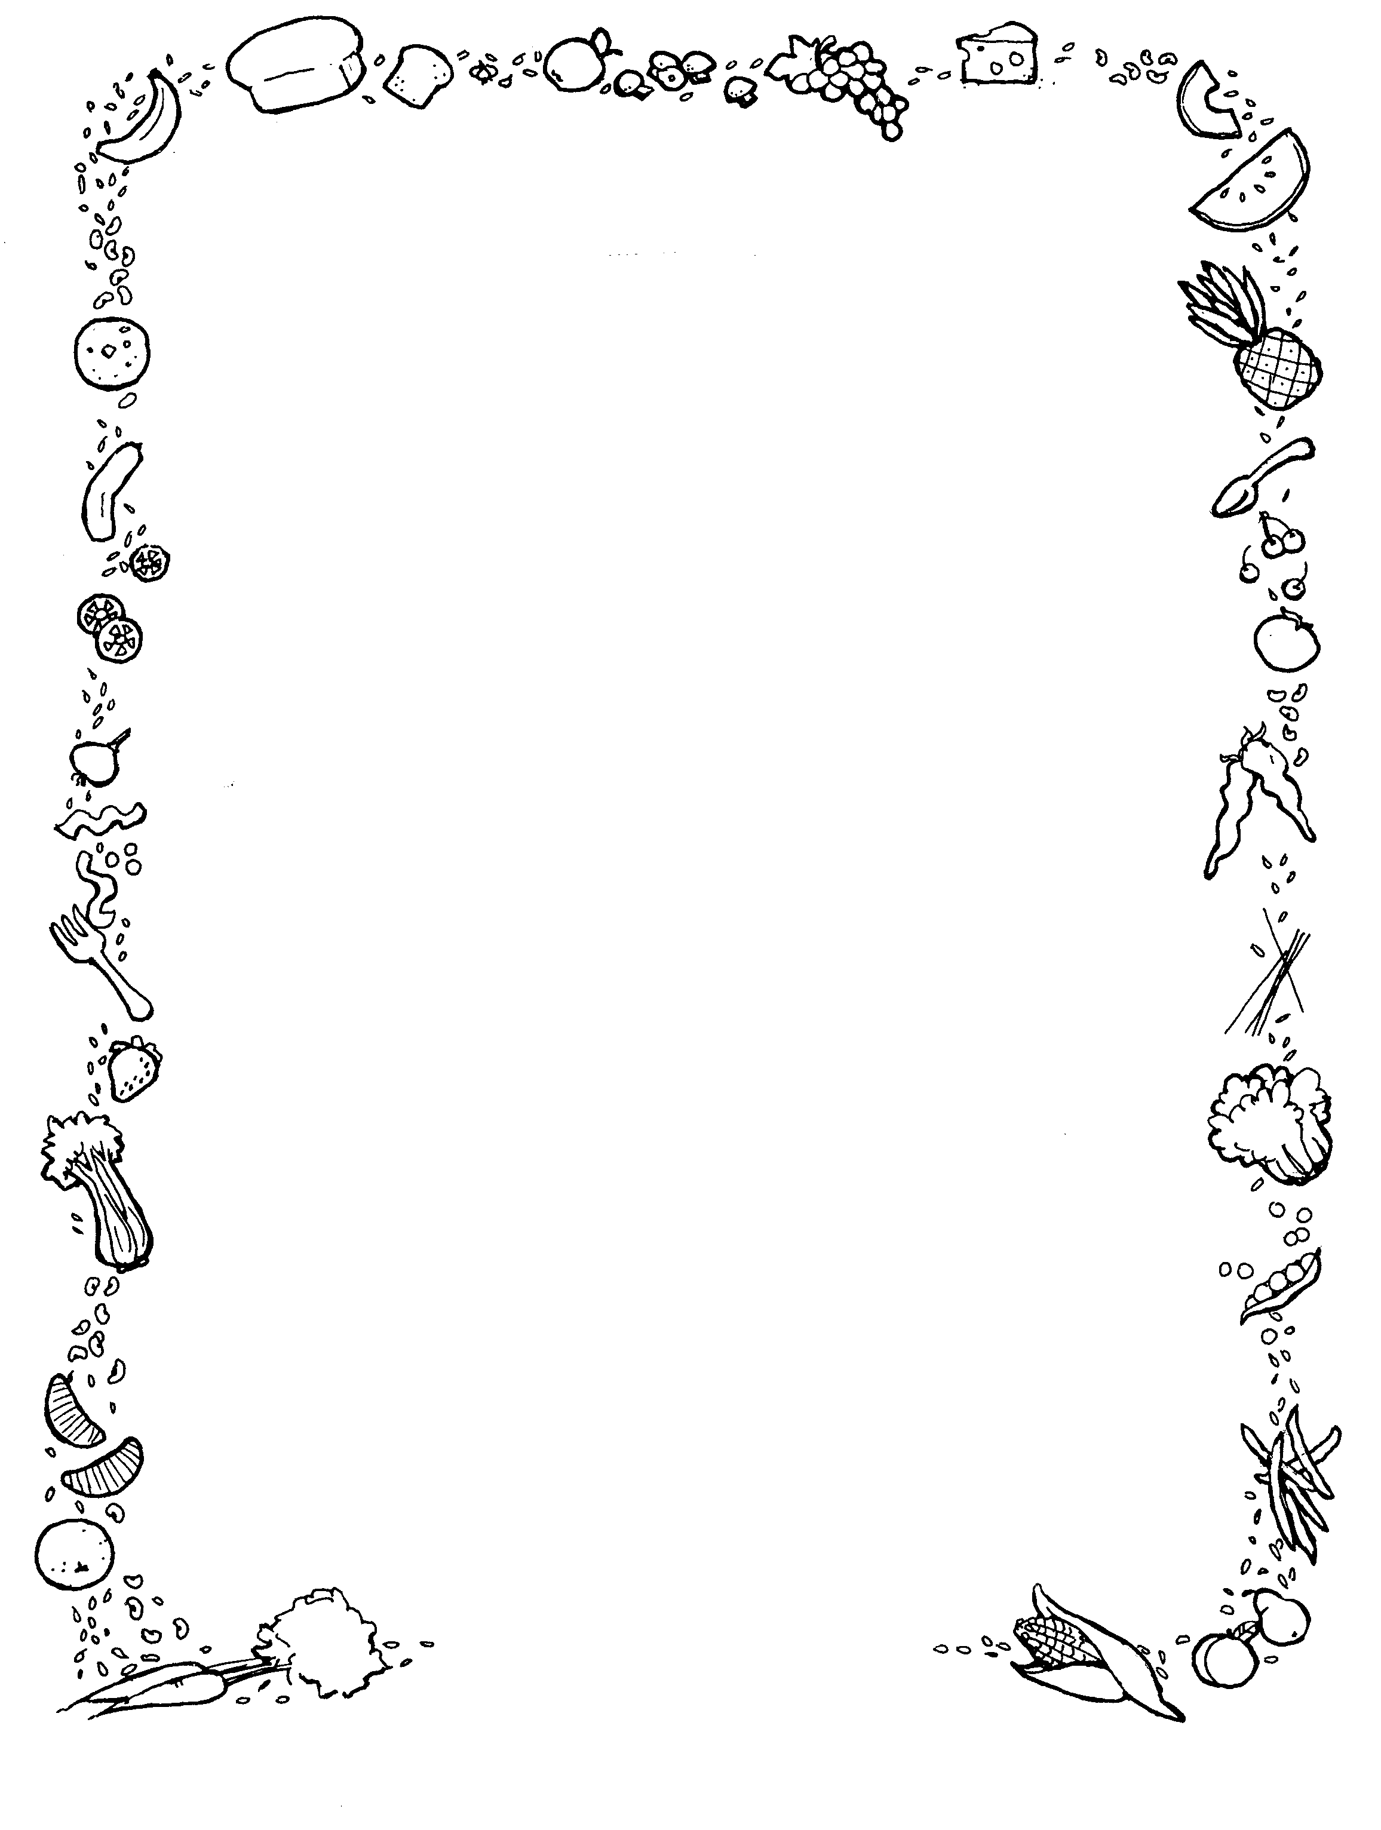

**WEEK 1**

**Monday**

**Main –** Meatballs and Pasta served with Garlic Bread

**Vegetarian-** Macaroni Cheese served with Garlic Bread

**Vegan –** 3 Bean Chilli served with Rice.

**Dessert of the Day-** Chocolate Brownie

**Tuesday**

**Main-** Chicken Enchilada Served with Salad & Coleslaw

**Vegetarian-** Quorn Enchilada Served with Salad & Coleslaw

**Vegan-** Jacket Potato

**Dessert of the Day-** Cheesecake

**Wednesday**

**Main-** Roast of the Day Served with all the Trimmings.

**Vegetarian-** Vegetable Risotto

**Vegan-** Beetroot, Red Pepper & Quinoa Burger

**Dessert of the Day-** Mixed Berry Crumble & Cream

**Thursday**

**Main-** Pulled Pork Served with Rice, Sweetcorn & Nachos

**Vegetarian-** Quorn Mince Served with Rice, Sweetcorn & Nachos

**Vegan-** Vegan Stew

**Dessert of the Day-** Syrup Sponge & Custard

**Friday**

**Main –** Fish or Nuggets & Chips Served with Beans or Curry Sauce

**Vegetarian-** Cheese & Mixed Pepper Quiche Served with Chips & Beans