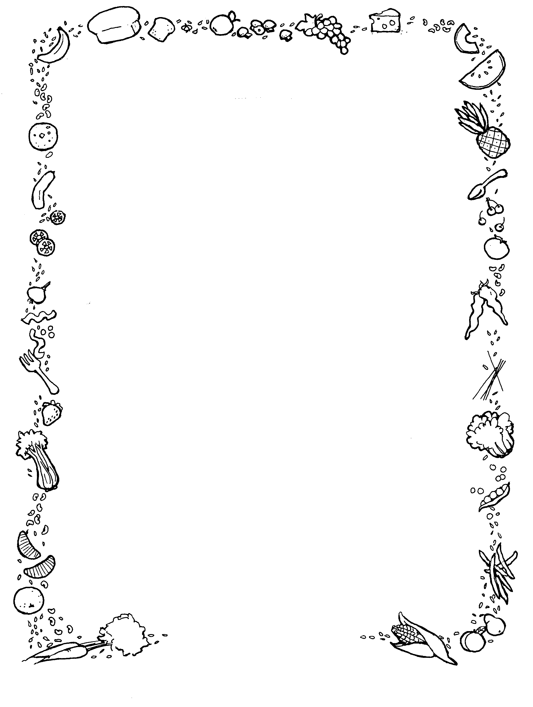

**Week 3**

**Monday**

**Main-** BBQ Chicken Thigh Served with Herby Dice & Salad/Sweetcorn

**Vegetarian-** Vegetable Tostada Served in Warm Tortilla

**Dessert of the Day-** Iced Vanilla Sponge

**Tuesday**

**Main-** Beef Lasagne Served with Salad/ Coleslaw

**Vegetarian-** Vegetable Lasagne Served with Salad & Coleslaw

**Dessert of the Day-** Toffee Cream Tart

**Wednesday**

**Main-** Roast of the Day Served with all the Trimmings.

**Vegetarian-** Quorn Cottage Pie Served with all the Trimmings.

**Vegan-** Jacket potato Served with BBQ Beans

**Dessert of the Day-** Chocolate Sundae

**Thursday**

**Main-** Chicken Chow Mein Served with Stir Fry Veg

**Vegetarian-** Quorn Chow Mein Served with Stir Fry Veg

**Vegan-** Vegetable Rice Served with Stir Fry Veg

**Dessert of the Day-** Fruity Flapjack

**Friday**

**Main-** Fish or Nuggets Served with Chips, Baked Beans or Curry Sauce

**Vegetarian-** Cheese & Tomato Quiche

**Vegan-** Chip Cone

**Dessert of the Day**