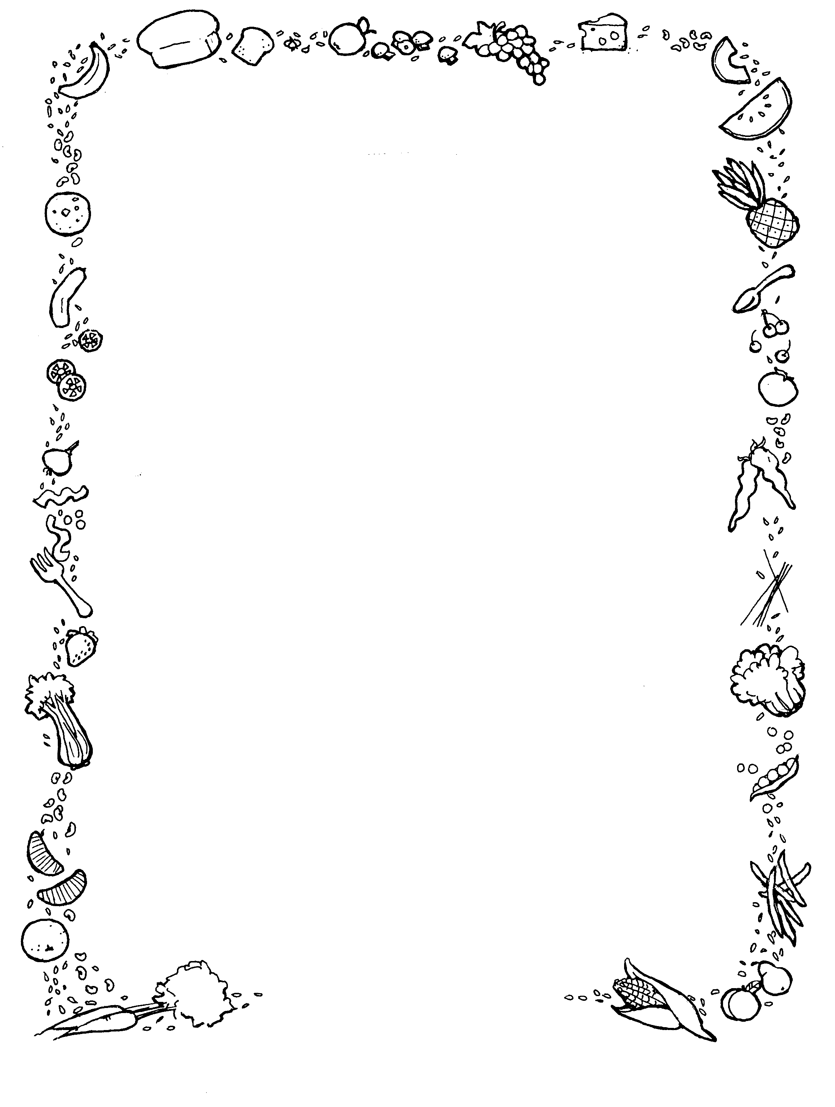

**Week 2**

**Monday**

**Main –** Chicken Tikka Masala Served with Rice & Mini Naan Bread

**Vegetarian-** Sweet Potato & Cauliflower Masala Served with Rice and Mini Naan Bread

**Vegan-** Beetroot, Red Pepper & Quinoa Burger Served with Salad

**Dessert of the Day-** Eton Mess

**Tuesday**

**Main-** Pasta Bolognese Served with Garlic Bread

**Vegetarian-** Quorn Bolognese Served with Garlic Bread

**Dessert of the Day-** Bakewell Tart

**Wednesday**

**Main-** Roast of the Day Served with all the Trimmings.

**Vegetarian-** Quorn Toad in the Hole Served with all the Trimmings.

**Vegan-** Paprika Roast Potato

**Dessert of the Day-** Chocolate Sponge & Chocolate Sauce

**Thursday**

**Main-** Hunters Chicken Served with Curly Fries & Peas

**Vegetarian-** Quorn BBQ Fillet Served with Curly fries & Peas.

**Dessert of the Day-** Apple Pie & Custard

**Friday**

**Main-** Fish or Nuggets Served with Chips Baked Beans or Curry Sauce

**Vegetarian-** Pasta Bake

**Dessert of the Day**