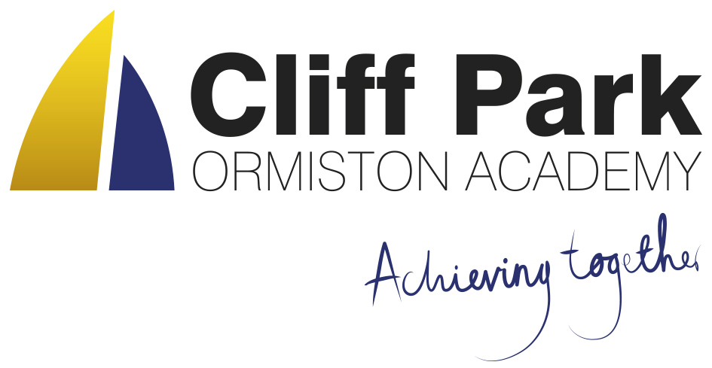

Kennedy Avenue, Gorleston-on-Sea  
Great Yarmouth, Norfolk NR31 6TA

Tel: 01493 661504  
Email: enquiries@cliffparkoa.co.uk  
Web: www.cliffparkoa.co.uk

11th October 2024

Dear Parents / Carers,

Welcome to our weekly newsletter.

I would like to take this opportunity to share some information about forthcoming events / dates for your diary.

**Year 11 Mock Exams start on Monday 14th November**

For our Year 11 students, how they approach this academic year will make a big difference to the GCSE grades they achieve, and help shape their future.

To get the best chance of success, parents/carers of Year 11 students are invited to attend a **Mock Exam Success Evening**  on Thursday 24th October 2024 from 6.00pm to 7.00pm.

At this informal presentation in the school hall, Mr French, Mr Sorrento and Mr Pillar will guide parents/carers and students through everything they need to know about revision and exam techniques to help them prepare and be ready before they start their mock exams in November.

Parents/carers play a vital role in our students’ revision study and their support is important in this crucial time before their exams, so we would encourage you to attend this evening.

**Student Successes**

**Year 7 Girls Netball**

Our Year 7 girls netball team had their first tournament on Monday this week against various local schools. There was excellent game play throughout and the progression throughout each game was superb. We won 1, drew 1 and lost 2. Well done team.

**U14s Girls Football**

On Thursday, our under 14s girls football team had their first fixture of the season against Ormiston Venture. We came away with a 3-1 loss however, for the first game playing together as a team there is plenty of potential. Looking forward to what the girls football team brings in their next fixture for the County Cup. A big shoutout as well to the Year 8s and Year 7s who stepped up to the plate to play above their age group. Well done.

**Medication in the Academy**

Please can we remind parents that students are not permitted to carry any form of medication with them around the academy. If your child needs to take any medication during the academy day please complete a medical form and leave the medication with main office. Student will be able to access the medication when required at break and lunch (or as directed by GP). Thank you in helping us to support the safety of our students.

**Anxiety workshop**

Wednesday 23rd October 10am-11am - we will be holding a parent workshop on Anxiety. This will be hosted by the NHS Mental Health School's Team and Mrs Huggins.  Come along to find out more about supporting your child with Anxiety and some strategies to help them overcome their fears.

Please email shuggins@cliffparkoa.co.uk to book your place.

**After School pick-ups**

If for some reason you are delayed or your child misses their ride home please can you ask them to return to the front office where a member of staff will help them. As the dark nights approach, we do not want students waiting outside on the road or being uncertain what to do in this situation.

**School Diner**

We are delighted with the positive response we have received from students regarding the new menus and food in the school diner.

We continue to offer a free breakfast for all our students. The Breakfast Club is available between 8.00AM and 8.25AM and all students are welcome.

**Please could I remind parents to make sure that you have placed sufficient funds on your child’s Parent Pay account to help maintain the smooth running of the checkouts.**

**Heads of Year**

If you need to contact your child’s head of year please email them or call the main reception to pass a message on for you.

Year 7 - Ms Phillips [ephillips@cliffparkoa.co.uk](mailto:ephillips@cliffparkoa.co.uk)

Year 8 - Mr Warnes [mwarnes@cliffparkoa.co.uk](mailto:mwarnes@cliffparkoa.co.uk)

Year 9 - Miss Harris [mharris@cliffparkoa.co.uk](mailto:mharris@cliffparkoa.co.uk)

Year 10 – Mrs Dudley [ddudley@cliffparkoa.co.uk](mailto:ddudley@cliffparkoa.co.uk)

Year 11 - Mr Callaby [rcallaby@cliffparkoa.co.uk](mailto:rcallaby@cliffparkoa.co.uk)

**Reminder for PE Kit**

A polite reminder that students must bring in their PE kit for all PE lessons. However hoodies are not acceptable due to health and safety.

**Knowledge Organisers**

Years 7, 8 and 9 all have their knowledge organisers. These are important documents that outline the core knowledge being studied in each of their subjects this half term. Students have been informed how the academy will be using the knowledge organisers, as well as how they can be used at home to help with their knowledge retention. Copies of the knowledge organisers and the six ways in which students can use them can be found on our website: [www.cliffparkoa.co.uk/curriculum/knowledge-organisers](https://cliffparkoa.co.uk/curriculum/knowledge-organisers)

Please discuss the knowledge organisers with your child; it is important they are viewed by students as an essential part of their daily table service. As outlined in the letter and through assemblies, students will receive a sanction for not having their knowledge organiser with them for each lesson.

**Punctuality Reminder**

**Students should be present on academy site by 8.30am**

Punctuality plays a vital role in your child's academic success and overall well-being. Arriving to school on time ensures that students can fully participate in all aspects of the learning experience, including morning routines, important announcements, and instructional time.

We understand that there may be occasional circumstances beyond your control that contribute to lateness. However, establishing and maintaining a consistent routine is essential in ensuring your child arrives at school on time each day.

**Uniform donation request**

We support our students and families by holding a bank of spare academy uniform for any student who needs it for whatever reason. We are asking for your help please. If you have any uniform that your child has grown out of and you would like to donate it to our uniform bank that would be amazing. Any donations can be given to our reception.

Thank you in advance for any support you can give us.

**SEND drop in reminder**

If you have any concerns or questions around SEND, Parents and Carers are invited to attend a SEND drop in session which is held at the academy every Tuesday morning 8.30 - 8.50am.

**Parent Drop In reminder**

Parents / Carers are welcome to drop into the academy to meet with myself or a member of my Senior Team every Wednesday. **You do not need to make an appointment, please just come to reception between 8.50 and 9.30AM and we will be happy to meet with you**. I understand the crucial role that parents play in a community school and welcome discussion on any aspect of our school community.

Unfortunately we will not be able to see parents who drop into reception outside of this period except where there is a safeguarding concern.

**Important Dates**

|  |  |
| --- | --- |
| **Date** | **Event** |
| Thursday 24th October | Mock Exam Success Evening |
| Thursday 14th November | Online Parent Forum |
| Thursday 16th January | Year 11 Mock Exam Information Evening |
| Thursday 6th February | Year 9 Parents/Options Evening |
| Thursday 20th March | Year 7 Parents Evening |
| Thursday 1st May | Year 8 Parents Evening |
| Thursday 15th May | Year 10 Parents Evening |

Thank you for supporting us in maintaining the high standards that we know you expect from Cliff Park Ormiston Academy.

Have a brilliant weekend

Yours sincerely

Harry French  
**Principal**