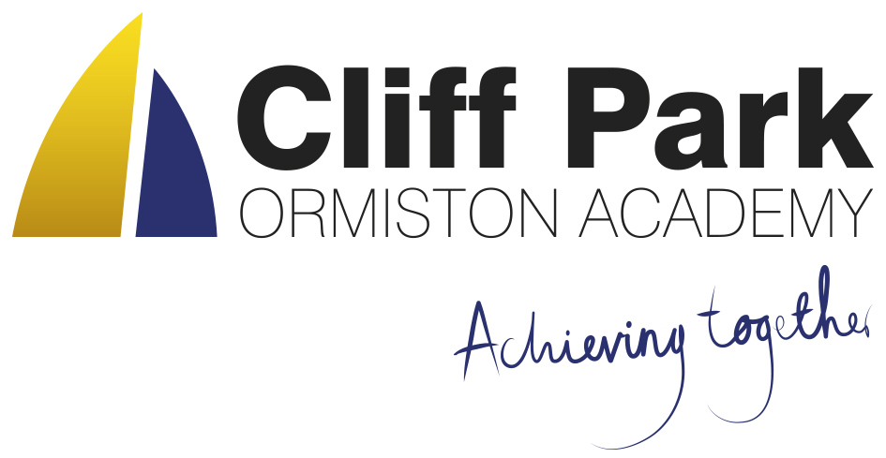

Kennedy Avenue, Gorleston-on-Sea  
Great Yarmouth, Norfolk NR31 6TA

Tel: 01493 661504  
Email: enquiries@cliffparkoa.co.uk  
Web: www.cliffparkoa.co.uk

20th September 2024

Dear Parents and Carers,

I hope you are well, and your child is enjoying the start of the new school year.

Over the past week, you may have seen some news relating to Ormiston Academies Trust’s approach to mobile phones in schools. I am writing today to share some further information on this and to clarify Cliff Park’s current position and direction the Trust is taking.

As you will no doubt be aware, mobile phones are increasingly being used by students both when at school and at home. However, a significant amount of research, including guidance from the Department for Education, clearly shows the negative impact this can have on student learning, behaviour, and wellbeing.

We all have a duty to create a learning environment which is calm, safe and free from distraction so all students, whatever their background, can learn and thrive. As such, moving forward it is the intention of Cliff Park to take steps to become completely smartphone-free later this term.

With this in mind, I would like to commence a consultation with you as parents and carers on introducing ‘Focus Smart Phone Pouches’ at Cliff Park.

**What are ‘Focus Smart Phone Pouches?**

The Focus Pouch is a durable protective mobile phone pouch which would be purchased for all students in the first instance. The pouch locks closed with a tamper proof magnetic locking mechanism. When the pouch is closed, it encases the child’s smart phone and any other smart devices inside the pouch and restricts the child’s access to them throughout the school day. The child keeps the focus pouch with them for the duration of the school day in their pocket or school bag. For those students who use their mobile phone for medical purposes e.g. automated measuring of blood sugar levels, a Velcro locking mechanism is available.

As the child leaves the school site they are able to tap the Focus Pouch on an unlocking station, releasing the magnet and providing the child access to their smart phone and other devices.

We want to hear what you and your child think. Would you please take a moment to complete the linked consultation questionnaire before Friday 27th September 2024. Furthermore, I would like to invite parents and carers to attend an online Parent Forum on Wednesday 25th September at 6.00pm where the pouches will be demonstrated.

**Link to consultation questionnaire:** [Link to Parent Consultation](https://forms.office.com/e/6Aj58e4tjW)

**Link to Parent Forum:** [Link to Parent Forum](https://teams.microsoft.com/dl/launcher/launcher.html?url=%2F_%23%2Fl%2Fmeetup-join%2F19%3Ameeting_MzE4OTYwN2ItZGQ5NC00YjE0LTg4ZjUtOTlmN2IwMTAyMTQ1%40thread.v2%2F0%3Fcontext%3D%257b%2522Tid%2522%253a%2522e8bb2c70-04dc-4893-8882-c47b54dbd292%2522%252c%2522Oid%2522%253a%2522b87642c6-af1d-487f-a856-52906158d85f%2522%257d%26anon%3Dtrue&type=meetup-join&deeplinkId=838ec8d9-4b92-459e-a80d-af71f46ea62c&directDl=true&msLaunch=true&enableMobilePage=true&suppressPrompt=true)

Parents will be updated throughout this consultation process and any changes in our current mobile phone policy will be communicated in advance of implementation.

If you have any questions, please do not hesitate to contact us. Thank you for your understanding and ongoing support as we strive to create an excellent learning environment for every student, every lesson at Cliff Park.

Yours faithfully,

Harry French  
**Principal.**