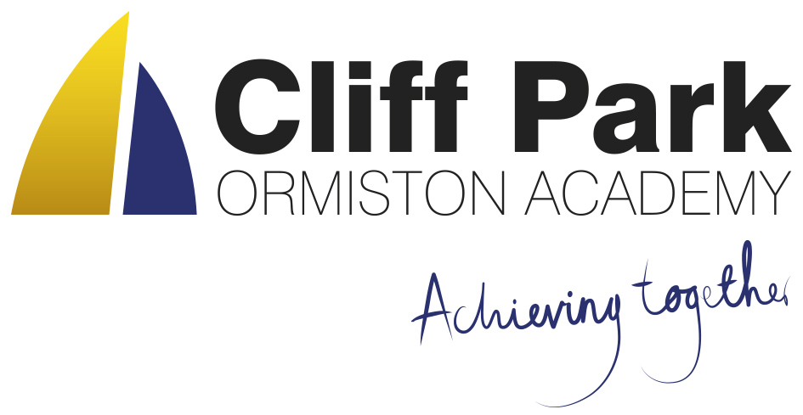

Kennedy Avenue, Gorleston-on-Sea  
Great Yarmouth, Norfolk NR31 6TA

Tel: 01493 661504  
Email: enquiries@cliffparkoa.co.uk  
Web: www.cliffparkoa.co.uk

20th September 2024

Dear Parents / Carers,

Welcome to our weekly newsletter.

I would like to take this opportunity to share some information about forthcoming events / dates for your diary.

It was wonderful to see so many Year 7 parents at our settling in evening last night. If you were unable to attend or have a concern please do not hesitate to contact the Yead of Year 7 Ms Phillips [Ephillips@cliffparkoa.co.uk](mailto:Ephillips@cliffparkoa.co.uk)

**Mobile Phones**

Over the past week, you may have seen some news relating to Ormiston Academies Trust’s approach to mobile phones in schools. I have written to all Parents / Carers today to share some further information on this and to clarify Cliff Park’s current position and direction the Trust is taking.

As you will no doubt be aware, mobile phones are increasingly being used by students both when at school and at home. However, a significant amount of research, including guidance from the Department for Education, clearly shows the negative impact this can have on student learning, behaviour, and wellbeing.

You are invited to contribute / ask questions at our Parent forum and questionnaire.

**Online Parents forum** – Wednesday 25th September at 6.00 pm [Link to Parent Forum](https://teams.microsoft.com/dl/launcher/launcher.html?url=%2F_%23%2Fl%2Fmeetup-join%2F19%3Ameeting_MzE4OTYwN2ItZGQ5NC00YjE0LTg4ZjUtOTlmN2IwMTAyMTQ1%40thread.v2%2F0%3Fcontext%3D%257b%2522Tid%2522%253a%2522e8bb2c70-04dc-4893-8882-c47b54dbd292%2522%252c%2522Oid%2522%253a%2522b87642c6-af1d-487f-a856-52906158d85f%2522%257d%26anon%3Dtrue&type=meetup-join&deeplinkId=838ec8d9-4b92-459e-a80d-af71f46ea62c&directDl=true&msLaunch=true&enableMobilePage=true&suppressPrompt=true)

**Link to consultation questionnaire** [Link to Parent Consultation](https://forms.office.com/e/6Aj58e4tjW)

**Karaoke Club**

Karaoke club will finish at 4.00 pm instead of 4.30 pm until further notice

**School Diner**

We are delighted with the positive response we have received from students regarding the new menus and food in the school diner.

We are delighted to continue to offer a free breakfast for all our students. The Breakfast Club is available between 8.00AM and 8.25AM and all students are welcome.

**Please could I remind parents to make sure that you have placed sufficient funds on your child’s Parent Pay account to help maintain the smooth running of the checkouts.**

**Year 11 Parents evening**

Year 11 parents evening is to be held on Thursday 26th September 2024. You will receive an invitation to book your appointments for your child’s subject teachers. Please contact the main reception if you have any problems regarding this.

**Heads of Year**

If you need to contact your child’s head of year please email them or call the main reception to pass a message on for you.

Year 7 - Ms Phillips [ephillips@cliffparkoa.co.uk](mailto:ephillips@cliffparkoa.co.uk)

Year 8 - Mr Warnes [mwarnes@cliffparkoa.co.uk](mailto:mwarnes@cliffparkoa.co.uk)

Year 9 - Miss Harris [mharris@cliffparkoa.co.uk](mailto:mharris@cliffparkoa.co.uk)

Year 10 – Mrs Dudley [ddudley@cliffparkoa.co.uk](mailto:ddudley@cliffparkoa.co.uk)

Year 11 - Mr Callaby [rcallaby@cliffparkoa.co.uk](mailto:rcallaby@cliffparkoa.co.uk)

**Reminder for PE Kit**

A polite reminder that students must bring in their PE kit for all PE lessons. However hoodies are not acceptable due to health and safety.

**Knowledge Organisers**

Years 7, 8 and 9 all have their knowledge organisers. These are important documents that outline the core knowledge being studied in each of their subjects this half term. Students have been informed how the academy will be using the knowledge organisers, as well as how they can be used at home to help with their knowledge retention. Copies of the knowledge organisers and the six ways in which students can use them can be found on our website: [www.cliffparkoa.co.uk/curriculum/knowledge-organisers](https://cliffparkoa.co.uk/curriculum/knowledge-organisers)

Please discuss the knowledge organisers with your child; it is important they are viewed by students as an essential part of their daily table service. As outlined in the letter and through assemblies, students will receive a sanction for not having their knowledge organiser with them for each lesson.

**Punctuality Reminder**

**Students should be present on academy site by 8.30am**

Punctuality plays a vital role in your child's academic success and overall well-being. Arriving to school on time ensures that students can fully participate in all aspects of the learning experience, including morning routines, important announcements, and instructional time.

We understand that there may be occasional circumstances beyond your control that contribute to lateness. However, establishing and maintaining a consistent routine is essential in ensuring your child arrives at school on time each day.

**Uniform donation request**

We support our students and families by holding a bank of spare academy uniform for any student who needs it for whatever reason. We are asking for your help please. If you have any uniform that your child has grown out of and you would like to donate it to our uniform bank that would be amazing. Any donations can be given to our reception.

Thank you in advance for any support you can give us.

**SEND drop in reminder**

If you have any concerns or questions around SEND, Parents and Carers are invited to attend a SEND drop in session which is held at the academy every Tuesday morning 8.30 - 8.50am.

**Parent Drop In reminder**

Parents / Carers are welcome to drop into the academy to meet with myself or a member of my Senior Team every Wednesday. **You do not need to make an appointment, please just come to reception between 8.50 and 9.30AM and we will be happy to meet with you**. I understand the crucial role that parents play in a community school and welcome discussion on any aspect of our school community.

Unfortunately we will not be able to see parents who drop into reception outside of this period except where there is a safeguarding concern.

**Important Dates**

|  |  |
| --- | --- |
| **Date** | **Event** |
| Thursday 26th September | Year 11 Parents Evening |
| Thursday 3rd October | Year 6 Open Evening |
| Thursday 14th November | Online Parent Forum |
| Thursday 16th January | Year 11 Mock Exam Information Evening |
| Thursday 6th February | Year 9 Parents/Options Evening |
| Thursday 10th March | Year 7 Parents Evening |
| Thursday 1st May | Year 8 Parents Evening |
| Thursday 15th May | Year 10 Parents Evening |

Thank you for supporting us in maintaining the high standards that we know you expect from Cliff Park Ormiston Academy.

Have a brilliant weekend

Yours sincerely

Harry French  
**Principal**