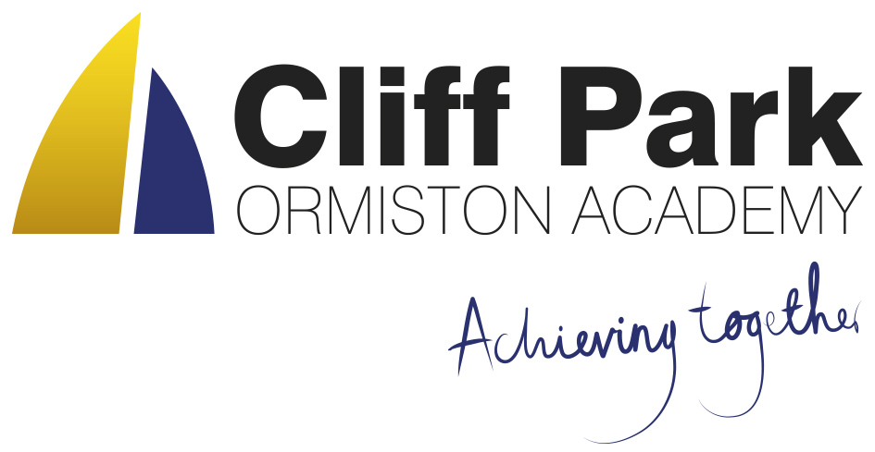
Kennedy Avenue, Gorleston-on-Sea
Great Yarmouth, Norfolk NR31 6TA
Tel: 01493 661504
Email: enquiries@cliffparkoa.co.uk
Web: www.cliffparkoa.co.uk

12th July 2024
Dear Parents / Carers,
Welcome to our weekly newsletter. I would like to take this opportunity to thank you for your continued support this half term and share some information about forthcoming events / dates for your diary.

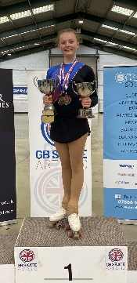
Student Success
Congratulations to Hope who competed at the Artistic Figure and
Free British Championships 2024 last weekend.
Hope has managed to retain her Espoir Ladies Figure and free titles,
winning in both categories. We are all very proud of her and wish her every success for the future.

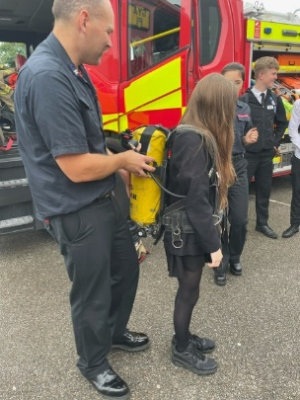
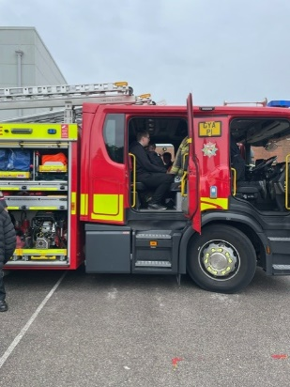

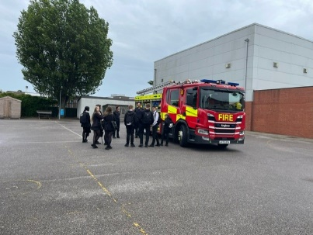

Fire brigade Visit
A big thank you to the local fire brigade who found time in their busy day to visit the Academy this week and spend some time with some of our students. We hope this was an inspirational experience.

Year 8 CEFAS Workshops
On Monday, Year 8 completed a number of workshops with CEFAS, the Government's centre for research into environment, fisheries and aquaculture. The workshops focused upon plastic pollution and how this is impacting upon our oceans. The workshops included:
- Training AI (drones) to detect litter
- Sieving sand for different sized plastics
- Exploring how different types of litter float and sink in our oceans
- How data is used to develop Government policies
The event was a real success, with 96% of students agreeing that they knew more about the topics covered than they did at the start of the workshops.
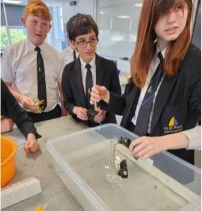
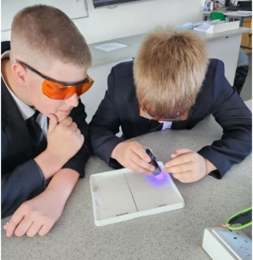

Party in the park last day of term
We are planning to hold an activity afternoon for all students on the last day of term. Students will attend normal lessons periods 1. 2 and 3. P4 will start with ‘form group parties’ until lunch. Students can take part in ‘Party in the Park’s from 1.00 pm until the end of the school day at 3.00 pm when students will be dismissed as usual.

We are arranging for an outdoor disco and ice cream van to attend in the afternoon therefore students will need to bring money if they wish to purchase an ice cream.

We will be holding a non -school uniform on this day and we request that students bring a can on the day. As always students should be reminded to wear sensible, appropriate clothing please.

Tie Colours for September 2024
Students currently attending Cliff Park will continue with the same colour tie for the rest of their time at the academy. The new year 7 students will have the purple stripe

Year 7 - Purple
Year 8 - Gold
Year 9 - Blue
Year 10 - Red
Year 11 - Green

Year 6 students transitioning into Year 7 can purchase ties from Harrisons School wear on Southtown Road, Great Yarmouth.

Reminder for PE Kit
A polite reminder that students must bring in their PE kit for all PE lessons. However hoodies are not acceptable due to health and safety.

Knowledge Organisers
Years 7, 8 and 9 all have their knowledge organisers. These are important documents that outline the core knowledge being studied in each of their subjects this half term.
Students have had an assembly outlining how the academy will be using the knowledge organisers, as well as how they can be used at home to help with their knowledge retention.
Copies of the knowledge organisers and the six ways in which students can use them can be found on our website: www.cliffparkoa.co.uk/curriculum/knowledge-organisers

Please discuss the knowledge organisers with your child; it is important they are viewed by students as an essential part of their daily table service. As outlined in the letter and through assemblies, students will receive a sanction for not having their knowledge organiser with them for each lesson.

Punctuality Reminder
Students should be present on academy site by 8.30am
Punctuality plays a vital role in your child's academic success and overall well-being. Arriving to school on time ensures that students can fully participate in all aspects of the learning experience, including morning routines, important announcements, and instructional time.

We understand that there may be occasional circumstances beyond your control that contribute to lateness. However, establishing and maintaining a consistent routine is essential in ensuring your child arrives at school on time each day.

Uniform donation request
We support our students and families by holding a bank of spare academy uniform for any student who needs it for whatever reason. We are asking for your help please. If you have any uniform that your child has grown out of and you would like to donate it to our uniform bank that would be amazing. Any donations can be given to our reception.
Thank you in advance for any support you can give us.

SEND drop in reminder
If you have any concerns or questions around SEND , Parents and Carers are invited to attend a SEND drop in session which is held at the academy every Tuesday morning 8.30 - 8.50am.

Parent Drop In reminder
Parents / Carers are welcome to drop into the academy to meet with myself or a member of my Senior Team every Wednesday. You do not need to make an appointment, please just come to reception between 8.50 and 9.30AM and we will be happy to meet with you. I understand the crucial role that parents play in a community school and welcome discussion on any aspect of our school community.
Unfortunately we will not be able to see parents who drop into reception outside of this period except where there is a safeguarding concern.

Important Dates
Date | Event
Friday 19th July | End of Term Students finish normal time of 3.00 pm
Wednesday 4th September | Start of the Autumn Term

Thank you for supporting us in maintaining the high standards that we know you expect from Cliff Park Ormiston Academy.
Have a brilliant weekend

Yours sincerely
Harry French
Principal

