Kennedy Avenue, Gorleston-on-Sea
Great Yarmouth, Norfolk NR31 6TA
Tel: 01493 661504
Email: enquiries@cliffparkoa.co.uk
Web: www.cliffparkoa.co.uk

28th June 2024
Dear Parents / Carers,
Welcome to our weekly newsletter. I would like to take this opportunity to thank you for your continued support this half term and share some information about forthcoming events / dates for your diary.

Myleene Klass Visit
We have been very fortunate since February 2023 to have had the opportunity to work closely with Myleene Klass, who is a former Cliff Park Ormiston Academy student. Myleene has attended several events at the academy and has been mentoring a small group of Year 11 students this year.
On Monday 24th June Myleene gave an inspirational talk to a group of our female students. This was well received, and many of the girls asked questions related to their future aspirations, feeling inspired about their futures.
Myleene very kindly arranged for all of our students to receive an ice cream, to acknowledge their hard work this year which was thoroughly enjoyed by everyone.
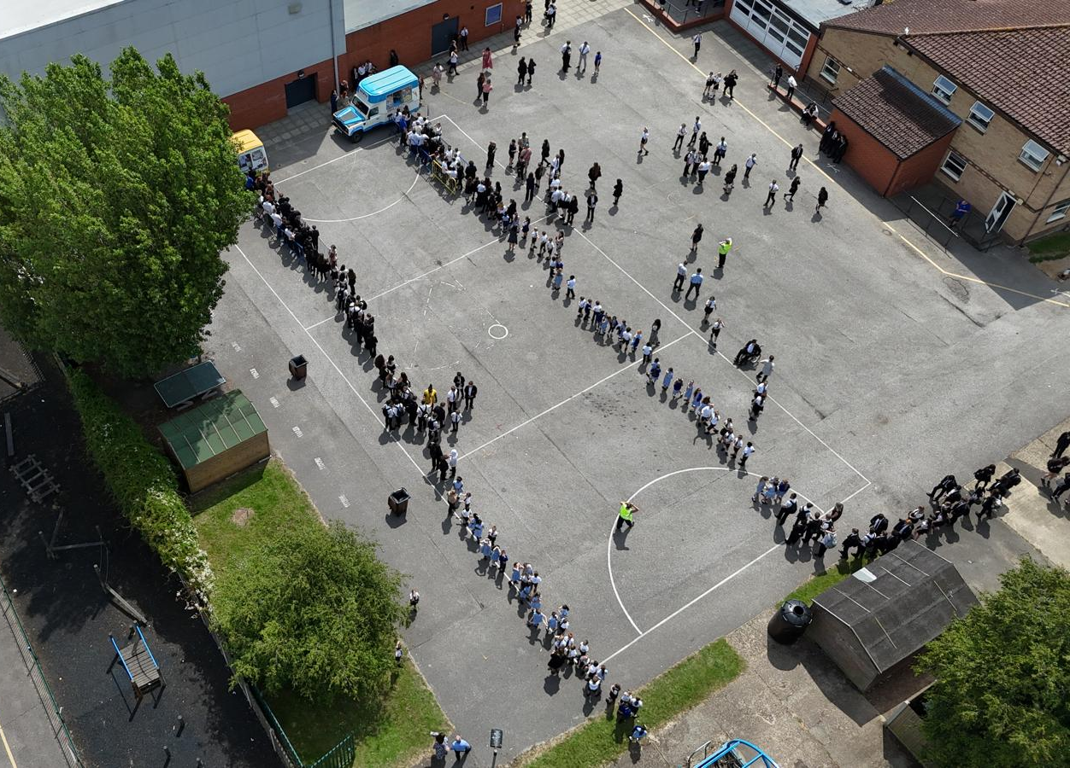
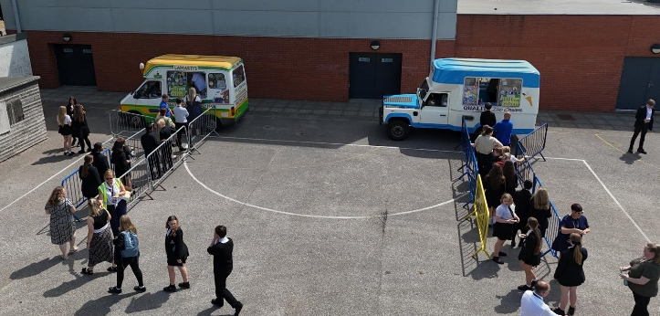

Reminder for PE Kit
A polite reminder that students must bring in their PE kit for all PE lessons. However hoodies are not acceptable due to health and safety.

Knowledge Organisers
Years 7, 8 and 9 all have their knowledge organisers. These are important documents that outline the core knowledge being studied in each of their subjects this half term.
Students have had an assembly outlining how the academy will be using the knowledge organisers, as well as how they can be used at home to help with their knowledge retention.
Copies of the knowledge organisers and the six ways in which students can use them can be found on our website: www.cliffparkoa.co.uk/curriculum/knowledge-organisers

Please discuss the knowledge organisers with your child; it is important they are viewed by students as an essential part of their daily table service. As outlined in the letter and through assemblies, students will receive a sanction for not having their knowledge organiser with them for each lesson.

Punctuality Reminder
Students should be present on academy site by 8.30am
Punctuality plays a vital role in your child's academic success and overall well-being. Arriving to school on time ensures that students can fully participate in all aspects of the learning experience, including morning routines, important announcements, and instructional time.

We understand that there may be occasional circumstances beyond your control that contribute to lateness. However, establishing and maintaining a consistent routine is essential in ensuring your child arrives at school on time each day.

Uniform donation request
We support our students and families by holding a bank of spare academy uniform for any student who needs it for whatever reason. We are asking for your help please. If you have any uniform that your child has grown out of and you would like to donate it to our uniform bank that would be amazing. Any donations can be given to our reception.
Thank you in advance for any support you can give us.

Parent Drop In reminder
Parents / Carers are welcome to drop into the academy to meet with myself or a member of my Senior Team every Wednesday. You do not need to make an appointment, please just come to reception between 8.50 and 9.30AM and we will be happy to meet with you. I understand the crucial role that parents play in a community school and welcome discussion on any aspect of our school community.
Unfortunately we will not be able to see parents who drop into reception outside of this period except where there is a safeguarding concern.

Important Dates
Date | Event
Monday 1st and Tuesday 2nd July | Year 6 transition days
Tuesday 2nd July | Y6 transition evening
Thursday 4th July | Year 11 Prom
Friday 19th July | End of Term

Thank you for supporting us in maintaining the high standards that we know you expect from Cliff Park Ormiston Academy.
Have a brilliant weekend

Yours sincerely

Harry French
Principal

