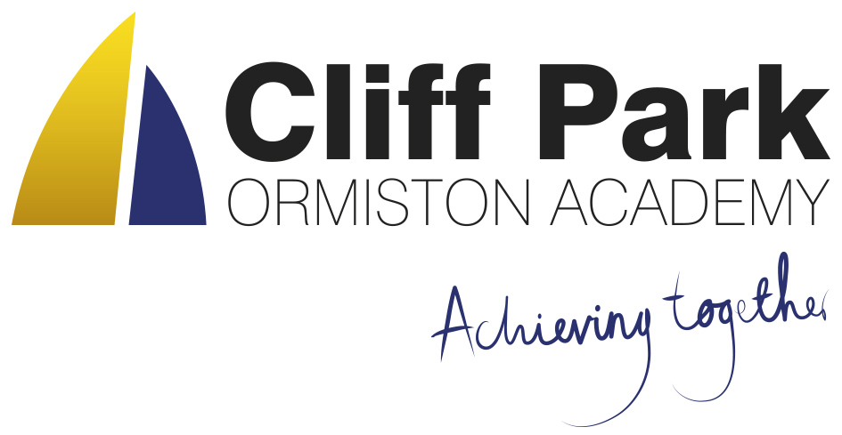
Kennedy Avenue, Gorleston-on-Sea
Great Yarmouth, Norfolk NR31 6TA
Tel: 01493 661504
Email: enquiries@cliffparkoa.co.uk
Web: www.cliffparkoa.co.uk

3rd May 2024
Dear Parents / Carers,
Welcome to our weekly newsletter. I would like to take this opportunity to thank you for your continued support and share some information about forthcoming events / dates for your diary.
Congratulations to our Year 8 Boys football team
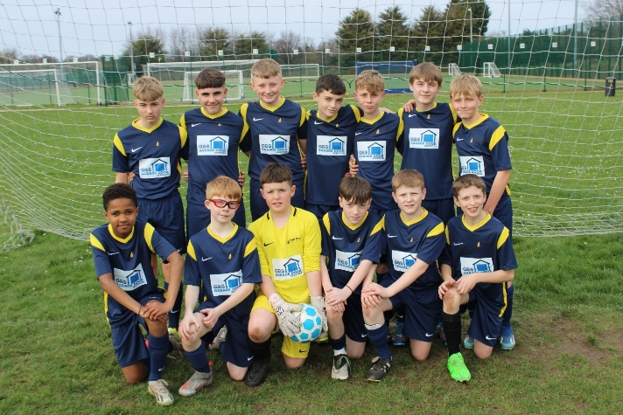
Cliff Park academy year 8’s boys recently won their first ever district league remaining unbeaten. This is a magnificent achievement; the boys have committed themselves throughout the whole season and have excelled individually. The district is made up of six schools where each school plays each other once. Cliff Park fixtures included Lynn Grove, Charter, Ormiston Venture, Caister High School and Flegg High Ormiston Academy. During these district games Cliff Park have only conceded 6 goals which is a huge achievement in itself. A massive congratulations to Cliff Park year 8’s!

Big shout out to G & S Garage Doors for their amazing sponsorship, they have enabled the team to compete in brand new football kits.

Great Big Green Week
As part of our commitment to the Eco-Schools initiative we have signed up to the Great Big Green Week in June.
I am doing another clothing collection to raise money for the Food Bank - if everybody brought me just 1 item of clothing they no longer wear (please ensure it is clean with no rips/holes), that would be approx 900 items of clothing and would raise a lot of money for the Food Bank, providing clothing for people in need, whilst also making a small difference to the environment.

Please advertise to your Form Groups and ask students if they could donate an item of clothing - I will run the collection until the week after half-term.

Reminder Change to lunch break times due to Y11 Exams
From today, Friday 3rd May 2024 Year 11 will be starting their exams. This means that for the duration of the exam period we will be moving our lunch break forward an hour to 12.20pm. Students will have their usual period 3, then lunch followed by period 4 and 5.

Knowledge Organisers
As outlined in our letter sent earlier in the week, Years 7, 8 and 9 have now received their knowledge organisers. These are important documents that outline the core knowledge being studied in each of their subjects this half term.

Students have had an assembly outlining how the academy will be using the knowledge organisers, as well as how they can be used at home to help with their knowledge retention.

Copies of the knowledge organisers and the six ways in which students can use them can be found on our website: www.cliffparkoa.co.uk/curriculum/knowledge-organisers

Please discuss the knowledge organisers with your child; it is important they are viewed by students as an essential part of their daily table service. As outlined in the letter and through assemblies, students will receive a sanction for not having their knowledge organiser with them for each lesson.

Mr Sorrento will be holding an online Parents' Forum on Wednesday 8th May at 6pm to explain the academy's use of them in more detail. The link to this meeting is: https://tinyurl.com/376h5pwr

Year 10 Work Experience
Year 10 Work Experience is fast approaching, taking place the week beginning Monday 10th June.
It is really important that students have now logged their placement onto Unifrog. This can be accessed through www.unifrog.org/student/placement. The information that is required to be entered is attached.

Students will not be able to go on Work Experience without the information being logged on our Unifrog system.
If you have any questions regarding the process, please do not hesitate to contact Mr Sorrento at ssorrento@cliffparkoao.co.uk.
We are also looking for parents who would be interested in helping with our pre-work experience workshops that will be taking place on Thursday 6th and Friday 7th June. As part of the workshops, we arrange students to have a mock interview experience from a range of different professions. If you would be able to support with this, please email Mr Sorrento for more information.

Punctuality Reminder
Students should be present on academy site by 8.30am
Punctuality plays a vital role in your child's academic success and overall well-being. Arriving to school on time ensures that students can fully participate in all aspects of the learning experience, including morning routines, important announcements, and instructional time.

We understand that there may be occasional circumstances beyond your control that contribute to lateness. However, establishing and maintaining a consistent routine is essential in ensuring your child arrives at school on time each day.

Uniform donation request
We support our students and families by holding a bank of spare academy uniform for any student who needs it for whatever reason. We are asking for your help please. If you have any uniform that your child has grown out of and you would like to donate it to our uniform bank that would be amazing. Any donations can be given to our reception.
Thank you in advance for any support you can give us.

Parent Forum
Our next Parent Forum will be taking place via Microsoft Teams on Thursday 16th May 2024 starting at 6.00PM. Meetings take place online. A link will be sent to all parents closer to the time.

Parent Drop In reminder
Parents / Carers are welcome to drop into the academy to meet with myself or a member of my Senior Team every Wednesday. You do not need to make an appointment, please just come to reception between 8.50 and 9.30AM and we will be happy to meet with you. I understand the crucial role that parents play in a community school and welcome discussion on any aspect of our school community.
Unfortunately we will not be able to see parents who drop into reception outside of this period except where there is a safeguarding concern.

Important Dates
Date | Event
Thursday 16th May | Online Parents Forum 6.00 pm
Monday 10th June to Friday 14th June | Year 10 work experience week
Monday 1st and Tuesday 2nd July | Year 6 transition days
Tuesday 2nd July | Y6 transition evening
Thursday 4th July | Year 11 Prom

Thank you for supporting us in maintaining the high standards that we know you expect from Cliff Park Ormiston Academy.
Have a brilliant weekend

Yours sincerely

Harry French
Principal

