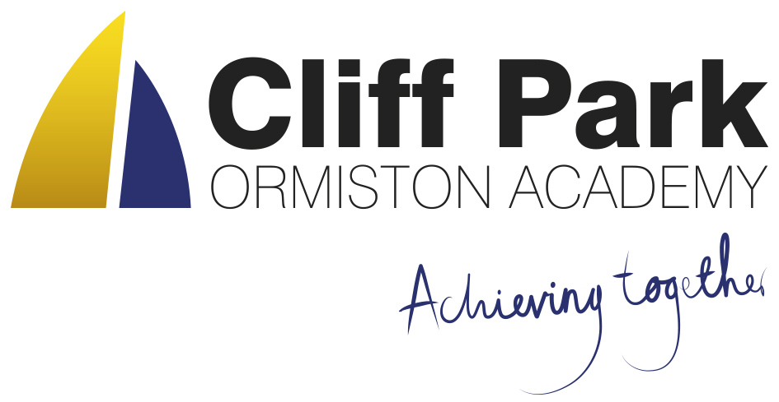
Kennedy Avenue, Gorleston-on-Sea
Great Yarmouth, Norfolk NR31 6TA
Tel: 01493 661504
Email: enquiries@cliffparkoa.co.uk
Web: www.cliffparkoa.co.uk

19th April 2024
Dear Parents / Carers
Welcome to our weekly newsletter. I would like to take this opportunity to thank you for your continued support and share some information about forthcoming events / dates for your diary.
Non-Uniform day 28th March 2024
The LRC staff at Cliff Park Ormiston Academy had a target of £80 to raise money for MIND charity. MIND charity is a charity who helps support and fight for people who struggle with their mental health.
With the help of the students and staff at Cliff Park we raised a total of £145 on the last day of term.
A massive well done and thank you to all students and parents for their donations.

Uniform donation request
We support our students and families by holding a bank of spare academy uniform for any student who needs it for whatever reason. We are asking for your help please. If you have any uniform that your child has grown out of and you would like to donate it to our uniform bank that would be amazing.

Year 10 Work Experience
Many students have now found a placement for their work experience week that starts on Monday 10th June. If your child is having difficulty finding a placement, please ask them to speak to Mr Sorrento for some support in finding a placement. Students must complete the attached sheet before half-term in order to get the process started.
Any donations can be given to our reception. Thank you in advance for any support you can give us.

Behaviour on Busses
We have received recent reports of poor behaviour and damage on some of the public busses that leave the James Paget Hospital at the end of the school day.

If your child uses a bus to travel to and from school, please can I ask that you have a conversation with your child about the importance of respectful behaviour in public spaces. I believe that by working together and addressing this issue promptly, we can ensure a safe and respectful environment for all passengers on the public bus.

Parent Forum
Our next Parent Forum will be taking place via Microsoft Teams on Thursday 16th May 2024 starting at 6.00PM. Meetings take place online. A link will be sent to all parents closer to the time.

Parent Drop In reminder
Parents / Carers are welcome to drop into the academy to meet with myself or a member of my Senior Team every Wednesday. You do not need to make an appointment, please just come to reception between 8.50 and 9.30AM and we will be happy to meet with you. I understand the crucial role that parents play in a community school and welcome discussion on any aspect of our school community.

Important Dates
Date | Event
Thursday 25th April | Year 8 Parents evening
Thursday 2nd May | Year 9 options 1:1 meetings
Thursday 9th May | Year 10 Parents evening
Thursday 16th May | Online Parents Forum 6.00 pm
Monday 10th June to Friday 14th June | Year 10 work experience week
Monday 1st and Tuesday 2nd July | Year 6 transition days
Tuesday 2nd July | Y6 transition evening
Thursday 4th July | Year 11 Prom

Thank you for supporting us in maintaining the high standards that we know you expect from Cliff Park Ormiston Academy.
Have a brilliant weekend

Yours sincerely

Harry French
Principal.

