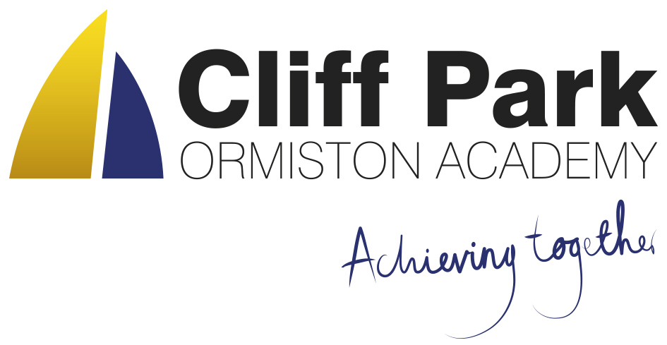
Kennedy Avenue, Gorleston-on-Sea
Great Yarmouth, Norfolk NR31 6TA
Tel: 01493 661504
Email: enquiries@cliffparkoa.co.uk
Web: www.cliffparkoa.co.uk

8th March 2024
Dear Parents / Carers
Welcome to our weekly newsletter. I would like to take this opportunity to thank you for your continued support and share some information about forthcoming events / dates for your diary.
Bystander Intervention Programme

Cliff Park Ormiston Academy are committed to providing a safe and secure environment in which your child can thrive and fulfil their potential. Similarly, we place a great deal of emphasis on our students’ well-being and personal development. To further support this, we have enrolled in an exciting new initiative: the Bystander Intervention Programme.
This programme is designed to teach our students to become Active Bystanders who can safely intervene to help fellow students. This programme has been embedded into our PSHE curriculum and lesson time has been allocated to teach our students about the problems associated with sexist language and the potential impact sexual harassment can have. The Active Bystander programme teaches students about the benefits of intervention, it also develops community spirit and helps to improve the wellbeing of all our students. Once students have learnt how to become Active Bystanders and be given the relevant skills necessary, they can choose whether they want to intervene to help their peers.
This Programme will be delivered in a workshop style session in year groups by Mr Sewell and Mrs Huggins and followed up with form time sessions in order to embed this learning. If you have any questions about the programme please email office@cliffparkoa.co.uk
The link below gives advice to parents about talking to their children about online sexual harassment
cco_talking_to_your_child_about_online_sexual_harassment_a-guide_for_parents_dec_2021.pdf (childrenscommissioner.gov.uk)
Year 9 Options
Option forms need to be handed in by Friday 22nd March. Forms must be signed by a parent. Copies of the booklet and form can be found on our website at https://cliffparkoa.co.uk/curriculum/ks4-guided-choices
On the website, students also have the option of submitting their choices on the electronic form. Please talk to your child about their option choices as they are able to hand their forms into Mr Sorrento at any time this half-term.

Year 10 Work Experience
Many students have now found a placement for their work experience week that starts on Monday 10th June. If your child is having difficulty finding a placement, please ask them to speak to Mr Sorrento for some support in finding a placement. Students must complete the attached sheet before half-term in order to get the process started.

Behaviour on Busses
We have received recent reports of poor behaviour and damage on some of the public busses that leave the James Paget Hospital at the end of the school day.

If your child uses a bus to travel to and from school, please can I ask that you have a conversation with your child about the importance of respectful behaviour in public spaces. I believe that by working together and addressing this issue promptly, we can ensure a safe and respectful environment for all passengers on the public bus.

Attendance and Punctuality
High levels of student attendance is vital for a successful school career. There is a clear link between academic performance and rates of attendance. Our school day begins at 8.50am and students are late to school if they arrive after this time. Students will receive an immediate sanction if they are late to school.
Our canteen is open from 8.00am for students to access a free breakfast and we would recommend that parents leave plenty of time if you are dropping students off with a car as the traffic outside of school can be heavy in the mornings. If there is an unavoidable reason for your child arriving late to school, please provide them with a note.
If you have any concerns linked to your child’s attendance there are a number of support strategies we can access to support you and your child. Please speak with us. Our Attendance team are more than happy to help and support with individual cases with a wide range of support on offer.
Our academy Attendance Policy it is available to download from the Cliff Park Ormiston Academy website.
Leave during term time
There is no entitlement in law for any leave of absence from the academy in term time. Taking leave in term time will affect a child’s education as much as any other absence and we expect parents to help them by not taking children away in term time. All applications for a leave of absence must be made in advance to the Principal and will only be considered if there are exceptional circumstances.

Parent Forum
Our next Parent Forum will be taking place via Microsoft Teams on Thursday 16th May 2024 starting at 6.00PM. Meetings take place online. A link will be sent to all parents closer to the time.

Parent Drop In reminder
Parents / Carers are welcome to drop into the academy to meet with myself or a member of my Senior Team every Wednesday. You do not need to make an appointment, please just come to reception between 8.50 and 9.30AM and we will be happy to meet with you. I understand the crucial role that parents play in a community school and welcome discussion on any aspect of our school community.

Important Dates
Date | Event
Thursday 14th March | Year 7 Parents Evening
Thursday 28th March | Finish for Easter Holiday
Monday 15th April | Return after Easter Holiday (Week 1)
Thursday 16th May | Online Parents Forum 6.00 pm

Thank you for supporting us in maintaining the high standards that we know you expect from Cliff Park Ormiston Academy.
Have a brilliant weekend

Yours sincerely

Harry French
Principal.

