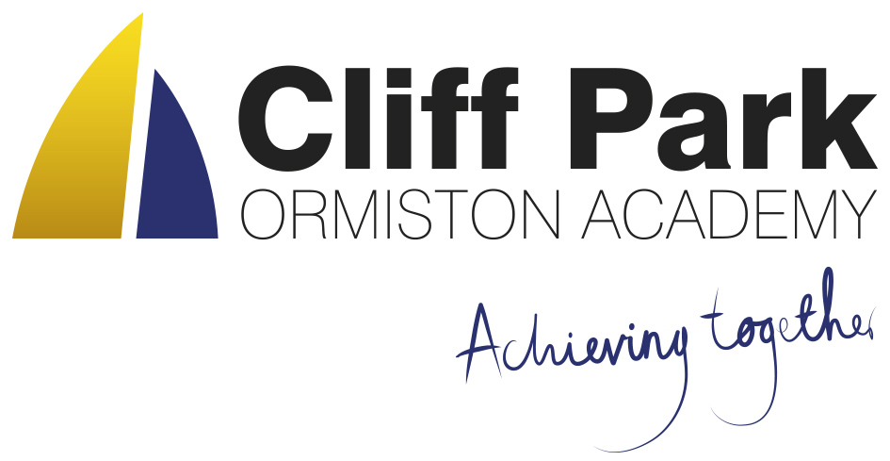
Kennedy Avenue, Gorleston-on-Sea
Great Yarmouth, Norfolk NR31 6TA
Tel: 01493 661504
Email: enquiries@cliffparkoa.co.uk
Web: www.cliffparkoa.co.uk

22nd March 2024
Dear Parents / Carers
Welcome to our weekly newsletter. I would like to take this opportunity to thank you for your continued support and share some information about forthcoming events / dates for your diary.
EASTER ATTENDANCE INCENTIVE - THE 9 DAYS OF EASTER
Our attendance incentive continues next week. Students have the chance to win an Easter Egg by being in school each day
Every day 2 students per year group will receive an Easter Egg for being in school. This will be announced in form the day after
On the last day of term, there will be an extra special prize per year group of Easter Egg Hamper
During the 9 days of Easter, each form group will compete against the rest of their year group for the best form attendance. The form in each year group with the best attendance for those 9 days will receive an Easter goodie on the afternoon of the last day of term
ATTENDANCE TO SCHOOL MATTERS
Parent Governor vacancy - Your school needs you!
Cliff Park Ormiston Academy has a vacancy for a parent governor.
Governors play a key role, working with the principal, staff and other governors to ensure that our school offers the best possible education for all its pupils.
- We welcome parents new to governance, or with prior experience.
- All parents and carers of registered pupils can apply, whether or not they live with the pupil.
- Someone who has parental responsibility or day-to-day care of a pupil is also eligible.
If there are more nominations than places, an election will be held in which all parents can vote.
Please contact J Spurgeon on 01493 660212 or email jspurgeon@cliffparkoa.co.uk for more details and a nomination form.

Non Uniform Day
On Thursday 28th we are holding a non-uniform day in support our community food bank. Students can wear sensible appropriate non uniform in exchange for non-perishable food items. Such as tins of soup, beans, vegetable, pasta, rice and toiletries etc.

Year 10 Work Experience
Many students have now found a placement for their work experience week that starts on Monday 10th June. If your child is having difficulty finding a placement, please ask them to speak to Mr Sorrento for some support in finding a placement. Students must complete the attached sheet before half-term in order to get the process started.

Behaviour on Busses
We have received recent reports of poor behaviour and damage on some of the public busses that leave the James Paget Hospital at the end of the school day.

If your child uses a bus to travel to and from school, please can I ask that you have a conversation with your child about the importance of respectful behaviour in public spaces. I believe that by working together and addressing this issue promptly, we can ensure a safe and respectful environment for all passengers on the public bus.

Parent Forum
Our next Parent Forum will be taking place via Microsoft Teams on Thursday 16th May 2024 starting at 6.00PM. Meetings take place online. A link will be sent to all parents closer to the time.

Parent Drop In reminder
Parents / Carers are welcome to drop into the academy to meet with myself or a member of my Senior Team every Wednesday. You do not need to make an appointment, please just come to reception between 8.50 and 9.30AM and we will be happy to meet with you. I understand the crucial role that parents play in a community school and welcome discussion on any aspect of our school community.

Important Dates
Date | Event
Thursday 28th March | Finish for Easter Holiday
Monday 15th April | Return after Easter Holiday (Week 1)
Thursday 25th April | Year 8 Parents evening
Thursday 2nd May | Year 9 options 1:1 meetings
Thursday 9th May | Year 10 Parents evening
Thursday 16th May | Online Parents Forum 6.00 pm

Thank you for supporting us in maintaining the high standards that we know you expect from Cliff Park Ormiston Academy.
Have a brilliant weekend

Yours sincerely

Harry French
Principal.

