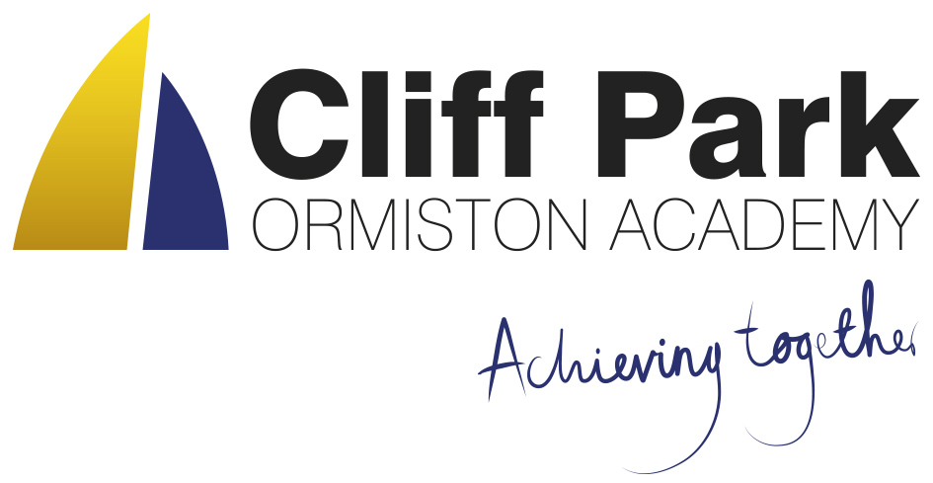
Kennedy Avenue, Gorleston-on-Sea
Great Yarmouth, Norfolk NR31 6TA
Tel: 01493 661504
Email: enquiries@cliffparkoa.co.uk
Web: www.cliffparkoa.co.uk

1st March 2024
Dear Parents / Carers
Welcome to our weekly newsletter. I would like to take this opportunity to thank you for your continued support and share some information about forthcoming events / dates for your diary.
National Careers Week
Next week is National Careers Week. As part of this, students will be completing some careers related act during Form Time. Students also have the opportunity to sign up to some 'Insight Into Industry' careers talks that will be taking place this half-term. The talks are from scientists and engineering who work at Cefas, the government’s marine and freshwater science experts.
Students have been shown a video about the company and have been encouraged to sign up through their Form Tutor to hear from the experts. More information about the company can be found here: https://www.cefas.co.uk/about-us/
Year 9 Options
This Wednesday, students had the opportunity to sample many of the subjects on offer to them next year. During this day, students received their options booklets and experienced tasters in Sociology, Hospitality, Art, Engineering, Media Studies, Travel and Tourism and Health and Social Care.
Students now have until Friday 22nd March to hand in their options forms that must be signed by a parent. Copies of the booklet and form can be found on our website at https://cliffparkoa.co.uk/curriculum/ks4-guided-choices

On the website, students also have the option of submitting their choices on the electronic form. Please talk to your child about their option choices as they are able to hand their forms into Mr Sorrento at any time this half-term.

Year 10 Work Experience
Many students have now found a placement for their work experience week that starts on Monday 10th June. If your child is having difficulty finding a placement, please ask them to speak to Mr Sorrento for some support in finding a placement. Students must complete the attached sheet before half-term in order to get the process started.

World Book Day
World Book Day is fast approaching. On Thursday March 7th, alongside all OAT academies, we will be celebrating a love of reading, offering students some exciting opportunities.

As always, there will be a Readathon - an annual event in which pupils are sponsored to read all day. It is a wonderful experience for our book worms and, of course, raises lots of money for charity, focusing mainly on supporting children in hospital with access to books and story tellers. Each year, our fabulous students sign up to take part to enjoy a whole day of reading whilst doing something amazing for others. Of course, this can only be done with your support - and the support of all sponsors. Students have been signing up all week and, if involved, will bring home a letter and a form. However, if you have any further questions, please contact me directly.

Another initiative running this year is an activity in which students are asked to complete different reading tasks each day during the week of World Book Day. You will see on Class Charts that, for pupils in Years 7-10, homework has been set that gives access to various texts - poems, diary entries, letters and such like. The idea is that, using the form attached as guidance, our young readers read an example of the specified text type and then bring the form to school to be signed off by their teacher. This is a great way to encourage a diversity in reading material which I hope you will support, making your own recommendations.

As always, thank you for you on-going support with reading at CPOA. Let's make World Book Day 2024 a real success!

Updates to Behaviour Management Procedures
The Behaviour Management Procedures that are used to consistently apply our behaviour processes have been updated. A copy of the procedures will be accessible on the academy website from Monday 26th February. Changes to the procedures include:
- Update to the guiding principles to include the academy’s approach to Trauma Informed Practice.
- Introduction of ‘Platinum Ticket’ Class Charts reward voucher.
- Adjustment of the behaviour pathway removing ‘Amber Remove’.
- Addition of ‘Off-Site Direction’ to another education provider to the procedure.
- Update to include the use of lunchtime detentions and changes to escalation processes if multiple detentions are missed.
- Addition of a verbal warning prior to confiscation of mobile phones.
- Updated processes to manage abusive behaviour from Parents / Carers.
Use of Off-Site Direction.
The academy has recently introduced the use of ‘Off Site Direction’ as a consequence short of suspension for some persistently poor behaviours. This provision allows the academy to direct students to another educational provision for up to three consecutive days to support improvements in their behaviour. The use of Off-Site Direction is set out in Section 29A Education Act 2002 and further defined in the Education (Educational Provision for Improving Behaviour) Regulations 2010 & The Education (Educational Provision for Improving Behaviour) (Amendment) Regulations 2012.

Cliff Park Ormiston Academy has partnership agreements in place with three local secondary academies including Ormiston Denes Academy (Lowestoft), Lynn Grove Academy (Gorleston) and Charter Academy (Great Yarmouth).

Parents / Carers will be informed before any off-site direction is issued.

Year 11 Mock Exams – Changes to Lunch break
When we return from February half term, Year 11 will be taking their next set of mock exams. In order to fully reflect what will happen in the summer exams we will be using the exam board start times of 9.00am and 1.30pm.

This means that for the two weeks after half term (Mon 26th Feb – Fri 8th March) we will be moving our lunch break forward an hour to 12.20pm. Students will have their usual period 3, then lunch followed by period 4 and 5.

Attendance and Punctuality
High levels of student attendance is vital for a successful school career. There is a clear link between academic performance and rates of attendance. Our school day begins at 8.50am and students are late to school if they arrive after this time. Students will receive an immediate sanction if they are late to school.
Our canteen is open from 8.00am for students to access a free breakfast and we would recommend that parents leave plenty of time if you are dropping students off with a car as the traffic outside of school can be heavy in the mornings. If there is an unavoidable reason for your child arriving late to school, please provide them with a note.
If you have any concerns linked to your child’s attendance there are a number of support strategies we can access to support you and your child. Please speak with us. Our Attendance team are more than happy to help and support with individual cases with a wide range of support on offer.
Our academy Attendance Policy it is available to download from the Cliff Park Ormiston Academy website.
Leave during term time
There is no entitlement in law for any leave of absence from the academy in term time. Taking leave in term time will affect a child’s education as much as any other absence and we expect parents to help them by not taking children away in term time. All applications for a leave of absence must be made in advance to the Principal and will only be considered if there are exceptional circumstances.
Parent Forum
Our next Parent Forum will be taking place via Microsoft Teams on Thursday 16th May 2024 starting at 6.00PM. Meetings take place online. A link will be sent to all parents closer to the time.
Parent Drop In reminder
Parents / Carers are welcome to drop into the academy to meet with myself or a member of my Senior Team every Wednesday. You do not need to make an appointment, please just come to reception between 8.50 and 9.30AM and we will be happy to meet with you. I understand the crucial role that parents play in a community school and welcome discussion on any aspect of our school community.

Important Dates

Date | Event
Thursday 14th March | Year 7 Parents Evening
Thursday 28th March | Finish for Easter Holiday
Monday 15th April | Return after Easter Holiday (Week 1)
Thursday 16th May | Online Parents Forum 6.00 pm

Thank you for supporting us in maintaining the high standards that we know you expect from Cliff Park Ormiston Academy.
Have a brilliant weekend

Yours sincerely

Harry French
Principal.

