8th December 2023
Welcome to our weekly newsletter. I would like to take this opportunity to thank all parents for your continued support and share some information about forthcoming events / dates for your diary.
Cliff Park Ormiston Academy Attendance Incentive
The 12 days of Christmas
We have launched our “12 Days of Christmas” attendance incentive this week. Students who are present for each of the 12 days of Christmas will be entered into a draw.
Up for grabs are: Vouchers for shops, chocolate bouquets, air Pods, a Fire HD Tablet and many more!
Please make sure your child attends for the 12 days of Christmas.
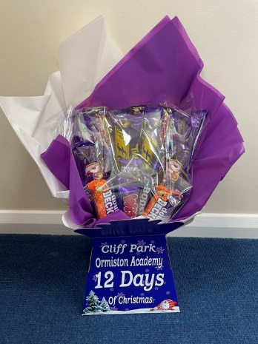

Christmas Hampers
A huge thank you to Cliff Park Community Church who have kindly donated 30 beautiful hampers to donate to families this Christmas. Thank you to Isobelle, Fred and Riley for helping Mr Pillar and Mr Shuffle this morning.

Papillion Garden Project
This week we had a visit from Trustees from the Papillion Project to see the fantastic garden our students have created with Matt and their incredible support. Thank you to Peter, Diane and Tom who met with our Principal Mr French.

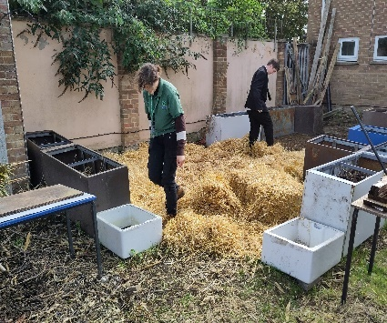

DofE Coastal Walk

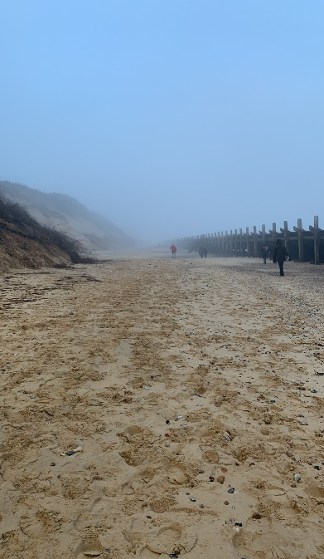
Congratulations to the bronze DofE students who took part in a taster day last Saturday. They experienced the distance required to complete part of their expedition next year. We drove down to East Point in the school minibus and then walked back to school. The outside temperature was cold, at zero degrees, with most of the route walked in misty conditions but the students made light of the weather. They walked the distance with ease and even enjoyed a hot chocolate picnic along the route. They impressed us all with their teamwork and resilience - well done to all of the bronze (and one silver) recruits!

Year 10 Work Experience
Year 10 Work Experience will be taking place during the week beginning 10th June 2024. Although it may seem that there is a long time left before this date, our experience has shown that the sooner students secure their placement the better!

We believe that Work Experience is really important as it gives students a valuable insight into the world of work.

Attached to this email is a copy of the letter that all students received this week. The letter contains a short form that students must complete when finding their work placement. This letter should then be returned to Mr Sorrento or Mr Sewell by 26th January 2024. Students will then have an opportunity to complete the online form in the new year using an online platform called 'Unifrog.'

If students require any help finding a placement, we are here to help them. However, we strongly encourage students to be proactive in finding their own placement as it builds up a positive relationship between them and the company.

Christmas Jumper day
On Wednesday 20th December 2023 we are holding a Christmas Jumper day to support our community food bank. Students can wear a Christmas jumper over their shirt and tie in place of their blazer in exchange for non perishable food items. Such as tins of soup, beans, vegetable, pasta, rice and toiletries.

Charity Bake Sale Friday 15th December
Students have asked if we can raise money to support Crisis Charity for the homeless community over the Christmas period, so we are holding a bake sale on Friday 15th December. Any donations are very welcome and can be given to Mr Shuffle at the academy.
Cakes will be sold for 50p or £1 and will be available for students to purchase at break and lunch time in the LRC

Request for Help - Parent Volunteers Needed
We are looking for volunteers to support the academy by assisting us with the school bus runs. We require an adult to sit on the busses with the students. If you are interested, please email Ms Spurgeon (jspurgeon@cliffparkoa.co.uk) for more details.

Plastic Bottle Tops
Can you help us – we are collecting plastic bottle tops for a project in our Design and Technology department. We need thousands so please save and send as many as you can.

Cut Your Carbon Campaign
Cliff Park have signed up to the "Cut your Carbon" national campaign. Please see recent email to parents for information about how students can get involved – several families have already completed the challenge!

Christmas Reward Shop for Students
We have now launched our Christmas Reward Shop where students can spend their rewards points to purchase gifts for family members and friends. The shop will open w/c 4th December
Donations of unwanted, unopened gifts can be brought into school and left with Mrs Huggins or Ms Engledow

Meeting with a member of staff
We aim to respond to phone calls and emails within 48 hours prioritising those that have a safeguarding concern – we ask for your patience, we will get back to everyone as soon as possible.

If you would like to meet in person with a member of staff - please call the academy in advance to book an appointment. Please see below. We are sorry but we are unable to see parents who come to reception without an appointment with the exception of Wednesday mornings when you can ask to see the Principal or a member of the Senior Leadership team during the advertised drop-in session. May I also remind parents that students booking in or out during the day need to use the student reception and not the main reception. Thank you for your cooperation.
Year 7 | Ms E Philips
Year 8 | Miss D Hall
Year 9 | Mr M Warnes
Year 10 | Mr S Cameron
Year 11 | Mr R Callaby

Download class charts to track your child’s behaviour and achievements
Class Charts will provide you with real-time information about your child’s achievements and informs you of any behaviour concerns immediately, if and when they happen. If you do not have an access code for Class Charts please contact reception.
You can access Class Charts by navigating to: https://www.classcharts.com/parent/login

Parent Pay Reminder – Student Lunches
Please can you ensure that there is sufficient funds loaded onto your child's parent pay each day for their lunch to avoid any disappointment. If you have any problems with parent pay please do not hesitate to contact the main office who will be happy to assist you.

Reminder of Upcoming Important Dates
Date | Event
Friday 15th December | Charity bake sale
Wednesday 20th December | Christmas Jumper day
Wednesday 20th December | End of Autumn Term
Thursday 4th January | Students return to the Academy (week 1)

Improving attendance and Punctuality
I would like to remind all parents and carers of their responsibilities to ensure that your child(ren) attend school every day. Attendance is mandatory for all pupils of compulsory school age. This means it is your legal duty as a parent to send your child to school regularly. By supporting your child’s attendance you will be supporting your child to achieve.

Please refer to the following table to calculate the impact of absence on your child’s attendance to lesson and missed learning:

An absence of …. | Leads to … | Which is | %
Missing a morning or afternoon session every two weeks. | 2 weeks of school missed over a full academic year or 50 hours of learning missed | 23 weeks of school missed over your child’s five year school career or 575 hours of learning missed | 95
Missing a day of school every two weeks | 4 weeks of school missed over a full academic year or 100 hours of learning missed | 47 weeks of school missed over your child’s five year school career or 1,175 hours of learning missed | 90
Missing a day of school every week | 8 weeks of school missed over a full academic year or 200 hours of learning missed | 91 weeks of school missed over your child’s five year school career or 2,275 hours of learning missed | 80

It is worth nothing that academic research suggests that just 17 days of absence across a five year school career will lead to a 1 grade reduction is academic performance for each of their subjects.

Our expectation for school attendance in 2023/24 is 96% and above for all students. We would like to see as many students as possible reach the 100% threshold and receive additional rewards and incentives for their hard work and commitment.

Students must be on site by 8.25am. Students who are late to school without a parental note or valid reason will be issued with a sanction on the same day that they arrived late to school.

Food Bank
If you find yourselves in need of additional support around food and toiletries, please contact the school office and we can arrange a food parcel for collection at our reception. The reception telephone number is 01493661504 or email enquiries@cliffparkoa.co.uk

Wednesday Morning Parent / Carer Drop In
Parents / Carers are welcome to drop into the academy to meet with myself or a member of my Senior Team every Wednesday. You do not need to make an appointment, please just come to reception between 8.50 and 9.30 am and I/we will be happy to meet with you. I understand the crucial role that parents play in a community school and welcome discussion on any aspect of our school community.
Thank you for supporting us in maintaining the high standards that we know you expect from Cliff Park Ormiston Academy.
Yours sincerely

Mr H French
Principal

Please see below term dates for 2023 - 2024
