7th July 2023
I would like to take this opportunity to thank you for your continued support and share some information about forthcoming events / dates for your diary.
Our Year 11 prom took place at the Parkhill Hotel yesterday evening. Our students looked amazing and had a wonderful time. They were a credit to us all. We wish them every success as they move onto the next part of their life journey and look forward to inviting them back to the academy in the Autumn Term for our awards evening.

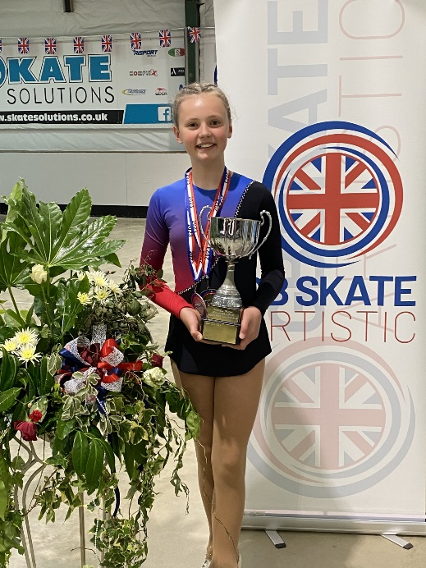
Congratulations Hope Watts who competed at the British championships last weekend for figures and free skating. Hope won and is British Champion in Free skating for 2023. We are all very proud of her and wish her well with all her future competitions.

Competition for students
Take a photograph and win an Amazon voucher, and see your photo published in the “Photo the World” calendar!
Photo the World” is an opportunity for pupils to take part in a competition to promote curiosity and fascination with the world around us. Winning entries will appear in a “Photo the World” calendar!
Please see copy of poster attached to this email for full details.
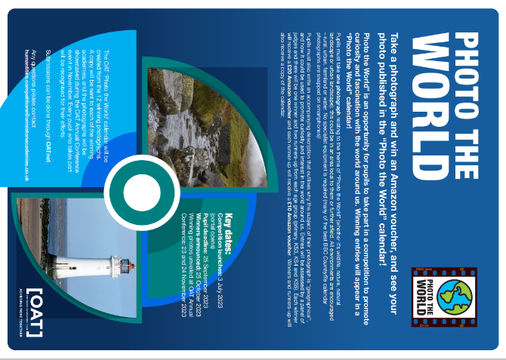

Thorpe Park Rewards Trip
30 cliff park student’s visited Thorpe park on Tuesday 4th July to celebrate their outstanding attendance this academic year. Students had a fantastic time and we look forward to running similar trips next year.
Reminder of Upcoming Important Dates
Monday 10th July – Parent forum online at 6.00PM on Teams

End of Term Arrangements
- 9.10am: Periods 1 as normal
- 10.10am: Period 2 as normal
- 11.10am: Break as normal
- 11.30am: Period 3 as normal
- 12.30pm-1.10pm: Lunch (40 minutes long to reflect next year’s lunch length)
- 1.10pm: Student to line up in their COMMUNITY LINE UPS. Picked up by Form Tutors for P4
- Form Party
- 2pm: Buses arrive, students leave

Trips and Visits
Pleasurewood Hills Year 7 - 20th July
Year 8 - 17th July
Year 9 - 14th July
Year 10 - 13th July

Changes to Academy Day Reminder
Starting from September the organisation of the academy day will be as follows:

8.30am | Line up and Form Time | 25 Minutes
8.55am | Period 1 | 60 Minutes
9.55am | Period 2 | 60 Minutes
10.55am | Break & Line Up | 25 Minutes
11.20am | Period 3 | 60 Minutes
12.20pm | Period 4 | 60 Minutes
1.20pm | Lunch & Line Up | 40 Minutes
2.00pm | Period 5 | 60 Minutes
3.00pm | End of School Day
TOTAL | 390 minutes (1950 Minutes) / 32.5 hours per week

Food Bank
If you find yourselves in need of additional support around food and toiletries, please contact the school office and we can arrange a food parcel for collection at our reception. The reception telephone number is 01493661504 or email enquiries@cliffparkoa.co.uk

Parent Drop-In
Reminder that 1:1 ‘Drop-In’ sessions are available with me or a senior member of the leadership team every Wednesday morning from 8.45 – 9.30 for anyone who wishes to see me to discuss any concerns they may have regarding their Son or Daughter. If this time is not convenient, please contact my PA Ms J Spurgeon to arrange an appointment.

Parent Forum
Our next online parent forum will take place on Monday 10th July 2023 at 6.00 pm and we look forward to seeing as many parents as possible.

Thank you for supporting us in maintaining the high standards that we know you expect from Cliff Park Ormiston Academy.
Yours sincerely
H French
Principal

Please see below term dates for 2023 - 2024
